**VIVEKANANDA INSTITUTE OF PROFESSIONAL STUDIES**

**VIVEKANANDA SCHOOL OF INFORMATION TECHNOLOGY**

VSIT

**BACHELOR OF COMPUTER APPLICATION**

**Prog. For problem solving Using C language**

**LAB FILE**

**Paper Code: BCA 101P**



**SUBMITTED TO: SUBMITTED BY:**

Dr. Pooja Saigal Gagan jha

Professor 03217702024

VSIT, VIPS BCA-I (A)

**INDEX**

|  |  |  |  |
| --- | --- | --- | --- |
| **P.No.** | **Title** | **Date (1A)** | **Signature** |
|  | **printf(), scanf()** |  |  |
| **1** | **WAP to demonstrate the usage of escape sequences (\n, \t, \b, \\, \", \')** | **22-Aug** |  |
| **2** | **WAP to study variables and constants of int and float data types** | **22-Aug** |  |
| **3** | **WAP to read two variables of type int and float. Read their values from the user and print the values** | **29-Aug** |  |
| **4** | **WAP to read two integers from user and print both the numbers. Find their sum and assign it to third variable** | **29-Aug** |  |
| **5** | **WAP to read numbers for five subjects and print their sum and average.** | **29-Aug** |  |
|  | **Data types and Operators** |  |  |
| **6** | **WAP to read two floating type numbers from user. Calculate their sum, difference, product and average** | **29-Aug** |  |
| **7** | **WAP to read Principle amount and time for a loan application. Take Rate of interest as a symbolic constant. Calculate Simple interest and display results** | **29-Aug** |  |
| **8** | **WAP to read temperature in Celsius and convert it to Fahrenheit and vice-versa. Display the results of the program** | **29-Aug** |  |
| **9** | **To swap two numbers using third variable** | **02-Sep** |  |
| **10** | **To swap two numbers without using third variable** | **02-Sep** |  |
| **11** | **Read input from user at runtime and convert time from -hours to seconds -hours to minutes -minutes to seconds** | **02-Sep** |  |
| **12** | **To find area and perimeter of rectangle. Read input from user** | **02-Sep** |  |
| **13** | **To print circumference and area of circle. Read input from user** | **02-Sep** |  |
| **14** | **To apply mathematical operation on ASCII value of character variables** | **09-Sep** |  |
| **15** | **Mathematical operation on character to get other character** | **09-Sep** |  |
| **16** | **WAP to read from user the values for 3 products (item_no, quantity, price). Find the total bill value and display. Also, allow a discount of 10% on the total bill and display net bill value** | **09-Sep** |  |
| **17** | **To find maximum of two numbers by using Conditional operator** | **23-Sep** |  |
| **18** | **To find maximum of three numbers using Conditional operator** | **23-Sep** |  |
|  | **if, if-else, nested if statements, switch-case** |  |  |
| **19** | **To find maximum of two numbers by using if else statement** | **23-Sep** |  |
| **20** | **To find maximum of three numbers by if else if statement** | **23-Sep** |  |
| **21** | **To find grades on the basis of marks, using if-else and relational operators Average marks Grade 80 to 100 Honours 60 to 79 First Division 50 to 59 Second Division 40 to 49 Third Division 0 to 39 Fail** | **23-Sep** |  |
| **22** | **To find electricity charges based on consumption Consumption Units Rate of Charge 0 – 200 Rs. 0.50 per unit 201 – 400 Rs. 100 plus Rs. 0.65 per unit excess of 200 401 – 600 Rs. 230 plus Rs. 0.80 per unit excess of 400 601 and above Rs. 390 plus Rs. 1.00 per unit excess of 600** | **23-Sep** |  |
| **23** | **WAP to read two integers and an operator (+,-,*,/,%). Use switch-case statement to get result of operator on two integers.** | **23-Sep** |  |
| **24** | **To find nature of roots of quadratic equations** | **23-Sep** |  |
|  | **while, do-while, for** |  |  |
| **25** | **WAP to print natural numbers till n using while loop. Also print reverse counting from m to 1. Get m,n from user at runtime** | **30-Sep** |  |
| **26** | **WAP to compute xn using while statement** | **30-Sep** |  |
| **27** | **WAP to generate multiplication tables using nested do-while statements** | **30-Sep** |  |
| **28** | **WAP to print following patterns: triangle of '*', triangle of digits** | **30-Sep** |  |
| **29** | **To read an integer and print sum of its digits using while loop. Construct and print reverse of n-digit number using do-while loop** | **30-Sep** |  |
| **30** | **To determine if given number is prime or composite** | **30-Sep** |  |
| **31** | **To print sum of first n odd natural numbers** | **30-Sep** |  |
| **32** | **To print sum of series: 1+1/2+…..+1/n** | **30-Sep** |  |
|  | **Functions** |  |  |
| **33** | **WAP to implement a function printline(int n,char ch) to print 'ch' n-times** | **07-Oct** |  |
| **34** | **program to find simple interest in a function. Create function with arguments and return type** | **07-Oct** |  |
| **35** | **Program to swap two numbers using functions (call by reference)** | **07-Oct** |  |
| **36** | **Program to find factorial of a number using function and return its value in the calling function** | **07-Oct** |  |
| **37** | **Program to find factorial of a number using recursion** | **07-Oct** |  |
| **38** | **Program to display usage of static variables** | **14-Oct** |  |
| **39** | **Program to display Fibonacci series using recursion** | **14-Oct** |  |
| **40** | **Programe to find all 3-digit Armstrong numbers** | **14-Oct** |  |
| **41** | **To read a number and check if it is odd or even (if-else)** | **14-Oct** |  |
| **42** | **To Check whether the given 5 digit number is a palindrome or not** | **14-Oct** |  |
|  | **Arrays** |  |  |
| **43** | **Program to show sum of n elements of array & show the average.** | **14-Oct** |  |
| **44** | **Program to find the maximum and minimum integer in an array using functions.** | **14-Oct** |  |
| **45** | **Program to perform Linear search on an array.** | **21-Oct** |  |
| **46** | **Program to generate reverse array for a given array.** | **21-Oct** |  |
| **47** | **Program to perform Matrix Operations (switch-case): Addition, Subtraction, Multiplication and Transpose** | **21-Oct** |  |
|  | **String Manipulation** |  |  |
| **48** | **Program to read character array using getchar() in do-while loop and print it. Find its length and number of vowels (Case-sensitive)** | **21-Oct** |  |
| **49** | **Program to find reverse of a string (without inbuilt function.)** | **21-Oct** |  |
| **50** | **Program to compare and concatenate two string (without inbuilt function)** | **21-Oct** |  |
| **51** | **Program to copy a string to another string (without inbuilt function.)** | **21-Oct** |  |
| **52** | **Program to show the use of string function: strcpy(), strcat(), strcmp(), strlen().** | **21-Oct** |  |
| **53** | **Program to find if a given string is palindrome or not.** | **21-Oct** |  |
|  | **Pointers** |  |  |
| **54** | **Program to define pointer variables for int, char and float. Print their values (using *) and addresses using pointers.** | **21-Oct** |  |
| **55** | **Program using pointers to read array elements and find their sum.** | **24-Oct** |  |
| **56** | **Program to find length of string using pointers.** | **24-Oct** |  |
| **57** | **Program to declare an array of pointers, read values and print them.** | **24-Oct** |  |
|  | **Structures** |  |  |
| **58** | **Program to enter book records, using structures** | **24-Oct** |  |
| **59** | **Program to enter employee salary records, using structures. Create array of structures** | **24-Oct** |  |
| **60** | **Program to define a structure stores and write a function update() to change the values of its members. (Pass structure to update() and return structure.)** | **24-Oct** |  |

**1. WAP to demonstrate the usage of escape sequences (\n,  \t, \b, \\, \", \')**

#include<stdio.h>

int main()

{

 printf("Gagan jha \t BCA 1A\n");

 printf("\n***************************************\n");

 printf("\nGoing to the next line\n");

 printf("Creating \t space");

 printf("\nRemoving last letter\b \n");

 printf("Adding backslash \\\n");

 printf("Adding single quote\'\n");

 printf("Adding double quote\"\n");

 return 0;

}

**OUTPUT**

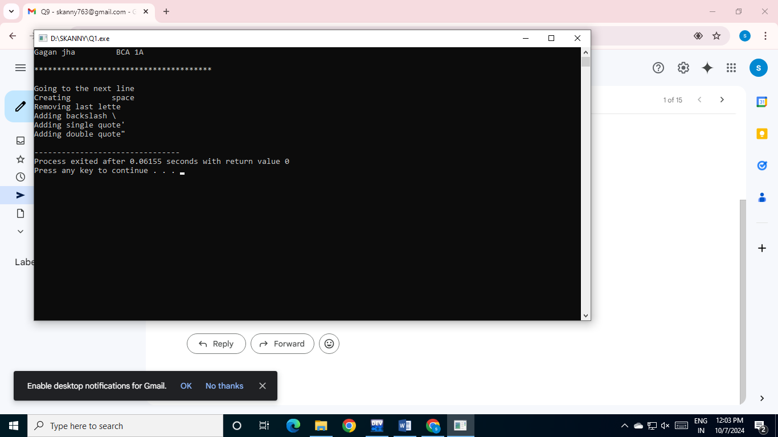

**2. WAP to study variables and constants of int and float  data types**

#include<stdio.h>

int main()

{

  printf("Gagan jha \t BCA 1A\n");

 printf("\n***************************************\n\n");

 int a,b;

 printf("Enter an integer:");

 scanf("%d", &a);

 printf("Value of an integer is %d\n",a);

 float c;

 printf("\nEnter float number:");

 scanf("%f", &c);

 printf("Value of a float number is %.2f",c);

 return 0;

}

**OUTPUT**

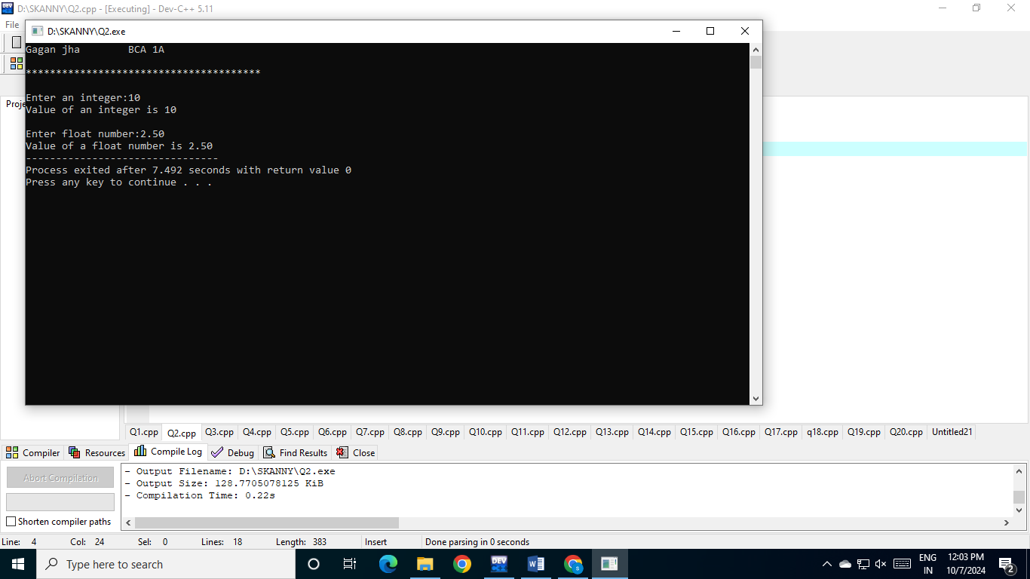

**3. WAP to read two variables of type int and float. Read  their values from the user and print the values C code**

#include<stdio.h>

int main() {

 printf("Gagan jha \t BCA 1A\n");

 printf("\n***************************************\n\n");

 int a,b;

 printf("Enter 1st number:");

 scanf("%d", &a);

 printf("Value of 1st number: %d\n",a);

 printf("Enter 2nd number:");

 scanf("%d", &b);

 printf("Value of 2nd number: %d\n",b);

 float c,d;

 printf("\nEnter float number:");

 scanf("%f", &c);

 printf("Float number: %.2f\n",c);

 printf("Enter float number:");

 scanf("%f", &d);

 printf("Float number: %.2f",d);

 return 0;

}

**OUTPUT**

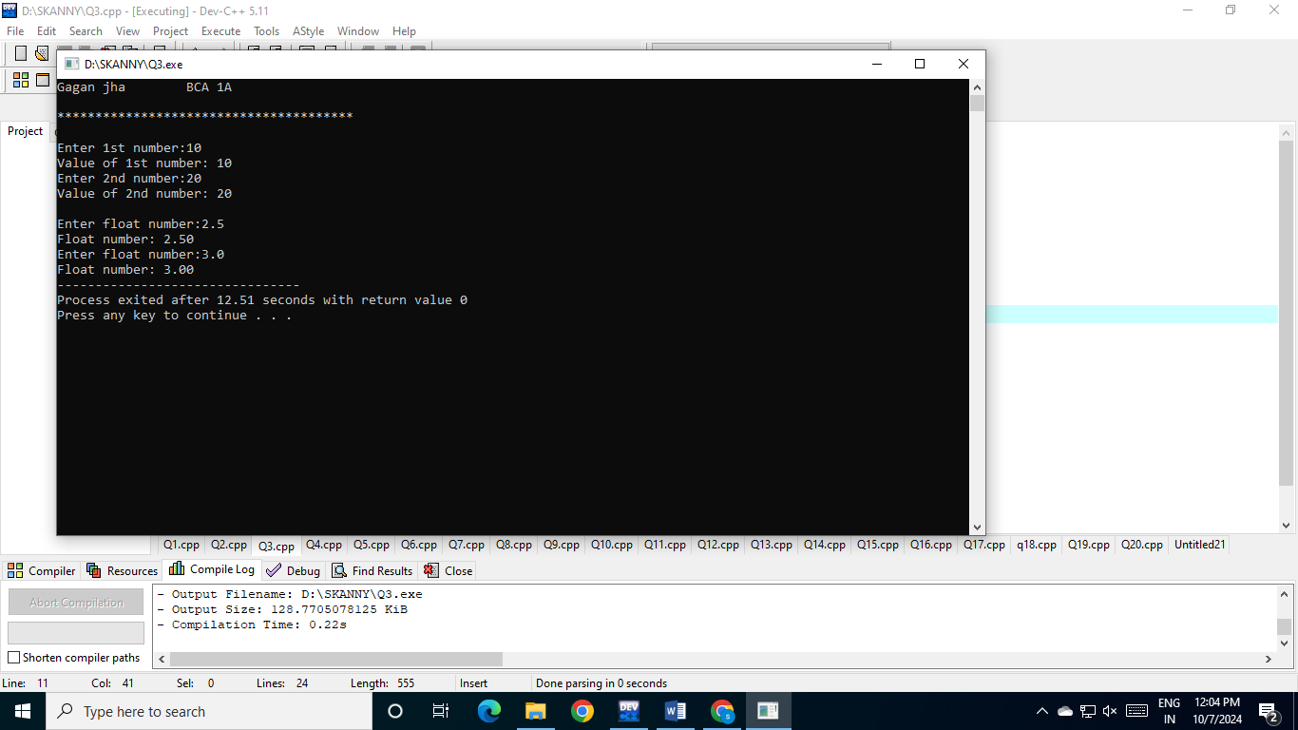

**4. WAP to read two integers from user and print both the  numbers. Find their sum and assign it to third variable.**

#include<stdio.h>

int main()

{

 printf("Gagan jha \t BCA 1A\n");

 printf("\n***************************************\n\n");

 int a,b,c,sum;

 printf("Enter 1st number:");

 scanf("%d", &a);

 printf("Value of 1st number: %d\n",a);

 printf("Enter 2nd number:");

 scanf("%d", &b);

 printf("Value of 2nd number: %d\n",b);

 sum = a+b;

 c = sum;

 printf("\nSum of %d and %d: %d", a,b,c);

 return 0;

}

**OUTPUT**

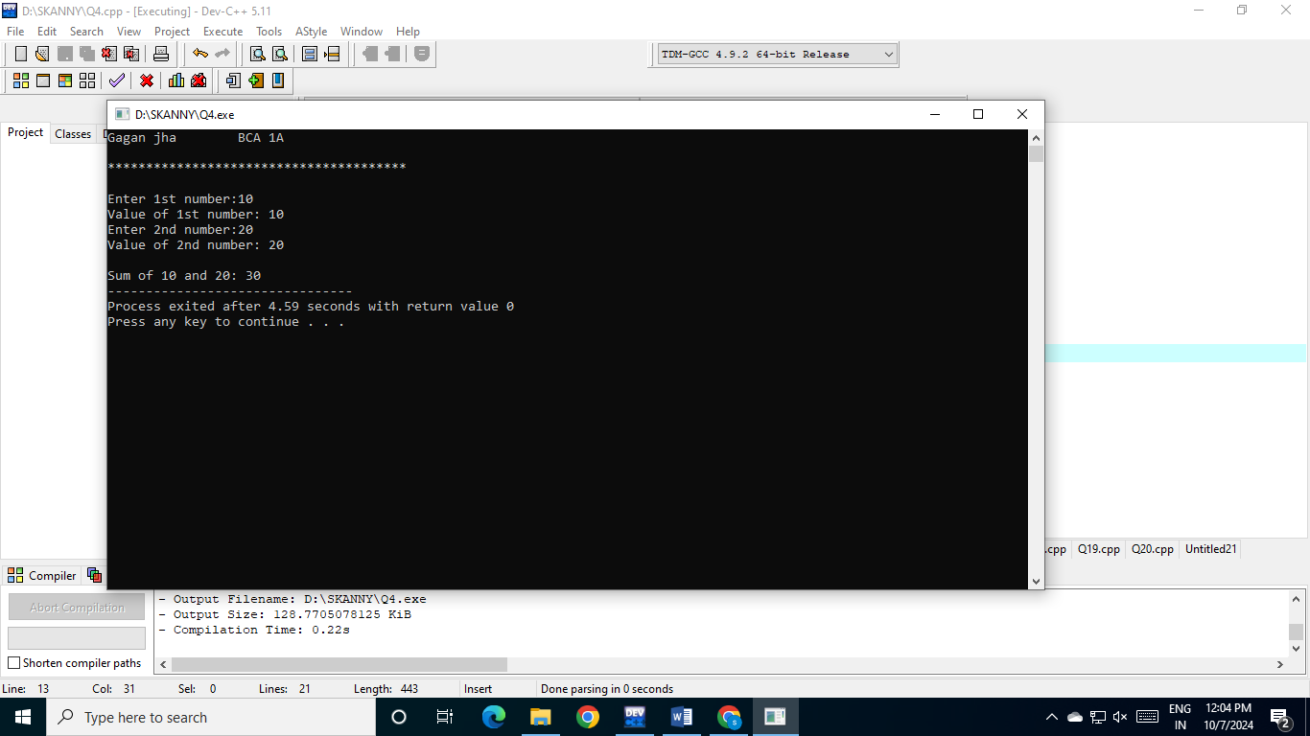

**5. WAP to read numbers for five subjects and print their  sum and average.**

#include<stdio.h>

int main() {

 printf("Gagan jha \t BCA 1A\n");

 printf("\n***************************************\n\n");

 int maths,physics,chemistry,cs,english,sum;

 float avg;

 printf("Marks in physics:");

 scanf("%d", &maths);

 printf("Marks in chemistry:");

 scanf("%d", &physics);

 printf("Marks in maths:");

 scanf("%d", &chemistry);

 printf("Marks in computer science:");

 scanf("%d", &cs);

 printf("Marks in english:");

 scanf("%d", &english);

 sum = maths+physics+chemistry+cs+english;

 avg = sum/5;

 printf("\nSum: %d\n",sum);

 printf("Average: %.2f",avg);

 return 0;

}

**OUTPUT**

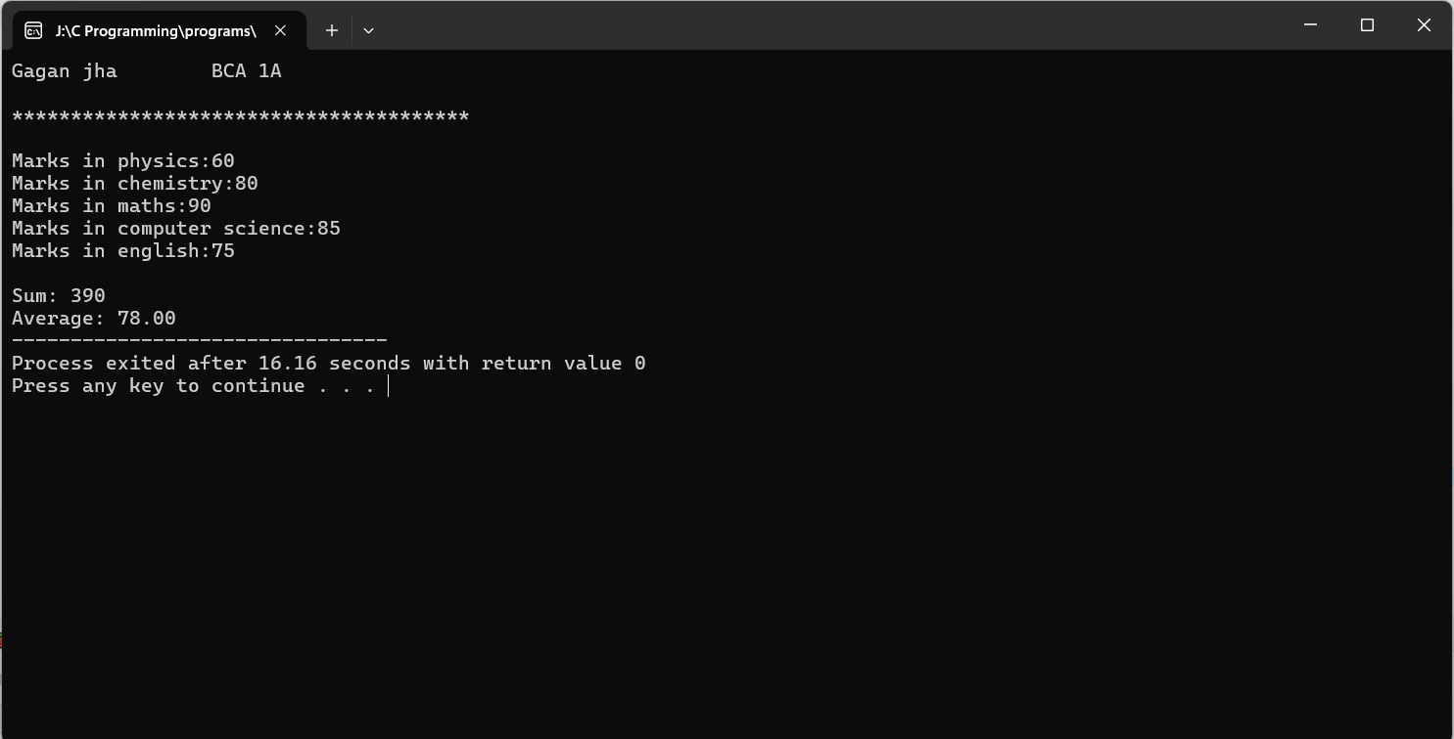

**6. WAP to read two floating type numbers from user.  Calculate their sum, difference, product and average.**

#include<stdio.h>

int main()

{

 printf("Gagan jha \t Class: BCA 1A\n");

 printf("\n***************************************\n\n");

 float num1,num2,sum,diff,prod,avg;

 printf("Enter 1st number:");

 scanf("%f", &num1);

 printf("Enter 2nd number:");

 scanf("%f", &num2);

 sum = num1+num2;

 diff = num1-num2;

 prod = num1*num2;

 avg = sum/2;

 printf("\nSum : %.2f", sum);

 printf("\nDifference : %.2f", diff);

 printf("\nProduct : %.2f", prod);

 printf("\nAverage : %.2f", avg);

 return 0;

}

**Output**

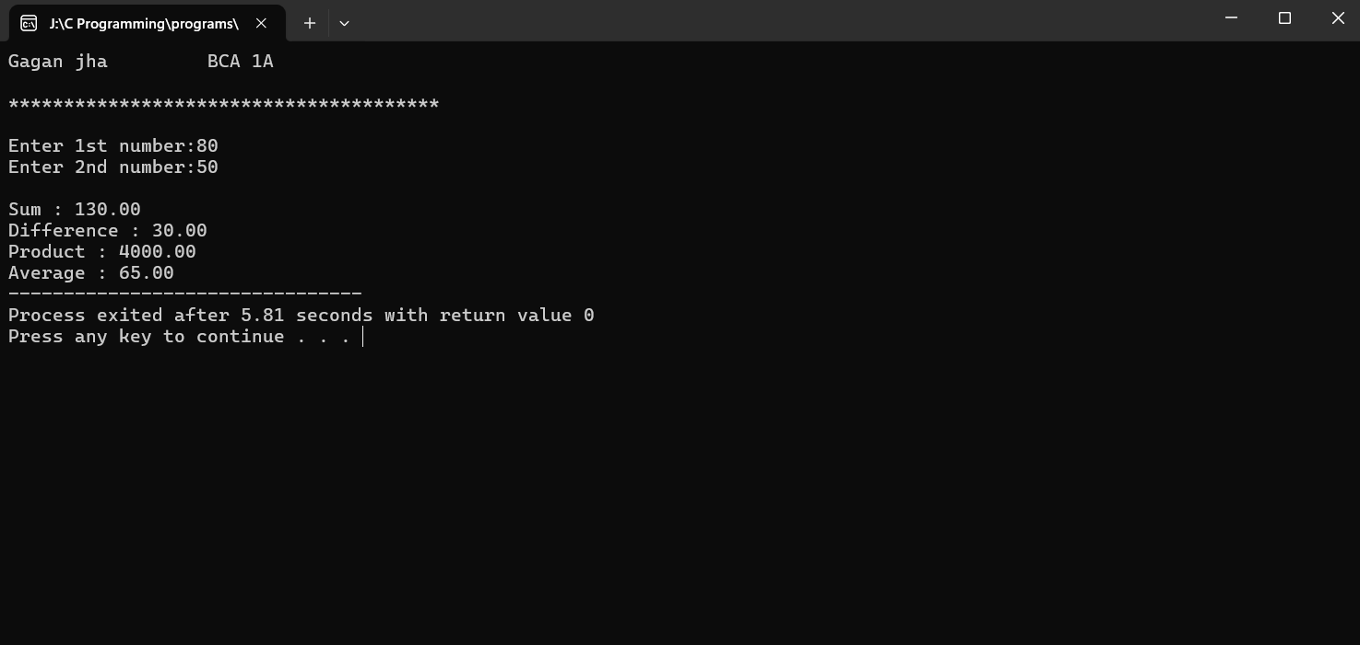

**7. WAP to read Principal amount and time for a loan  application. Take Rate of interest as a symbolic  constant. Calculate Simple interest and display results.**

#include<stdio.h>

#define ROI 10

int main() {

printf("Gagan jha \t Class: BCA 1A\n");

printf("\n***************************************\n\n");

float amount,time,SI;

printf("Enter principle amount:");

scanf("%f", &amount);

printf("Enter time (in years):");

scanf("%f", &time);

SI= (amount*time*ROI)/ 100.0;

printf("\nSimple Interest IS :%.2f",SI);

return 0;

}

**OUTPUT**

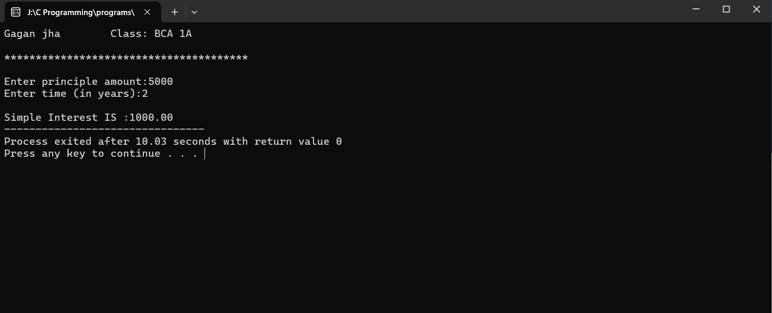

**8. WAP to read temperature in Celcius and convert it to  Farenheit and vice-versa. Display the results of the  program**

#include<stdio.h>

int main() {

  printf("Gagan jha \t Class: BCA 1A\n");

 printf("\n***************************************\n\n");

 float C,F;

 printf("Enter the value of temprature in fahrenheit:");

 scanf("%f",&F);

 C=(F-32)*5/9;

 printf("%f\n",C);

 printf("enter the value of temprature in celsius:");

 scanf("%f",&C);

 F=C*9/5+32;

 printf("%f",F);

 return 0 ;

}

**OUTPUT**

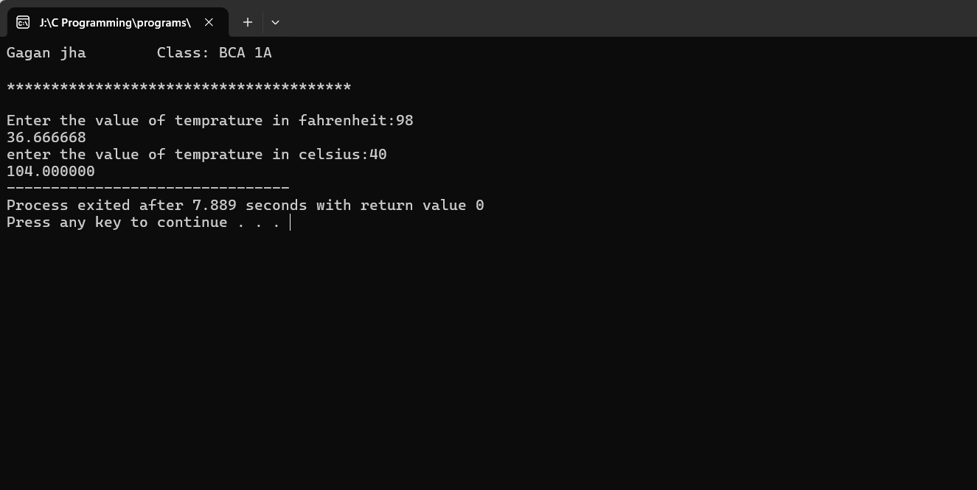

**9. To swap two numbers using third variable**

#include<stdio.h>

int main() {

printf("Gagan jha \t Class: BCA 1A\n");

printf("\n***************************************\n\n");

int x,y,z;

printf("Enter value of x: ");

scanf("%d", &x);

printf("Enter value of y: ");

scanf("%d", &y);

z=x;

x=y;

y=z;

printf("x: %d\n",x);

printf("y: %d\n",y);

return 0;

}

**OUTPUT**

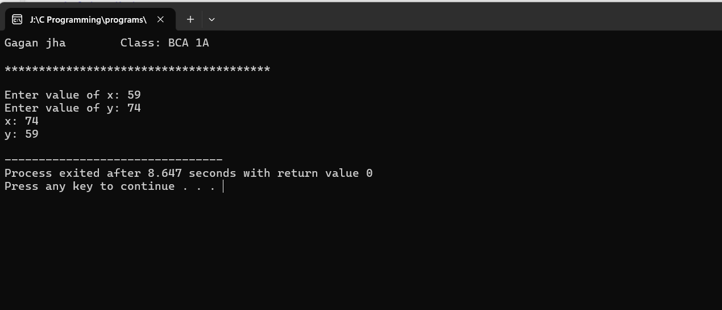

**10. To swap two numbers without using third variable** #include<stdio.h>

int main() {

  printf("Gagan jha \t Class: BCA 1A\n");

 printf("\n***************************************\n\n");

 int a,b;

 printf("Enter value of a: ");

 scanf("%d", &a);

 printf("Enter value of b: ");

 scanf("%d", &b);

 a=a+b;

 b=a-b;

 a=a-b;

 printf("a: %d\n",a);

 printf("b: %d\n",b);

 return 0;

}

**OUTPUT**

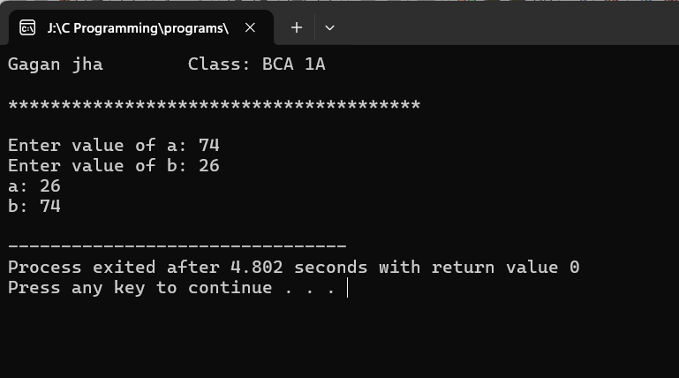

**11. Read input from user at runtime and convert time  from**

**-hours to seconds**

**-hours to minutes**

**-minutes to seconds**

#include<stdio.h>

int main() {

 printf("Gagan jha \t Class: BCA 1A\n");

  printf("\n***************************************\n\n");

 float hrs,min,sec;

 printf("Enter Hours:");

 scanf("%f", &hrs);

 sec = hrs * 60 * 60;

 printf("Seconds: %.2f\n",sec);

 printf("\nEnter Hours:");

 scanf("%f", &hrs);

 min = hrs * 60;

 printf("Minutes: %.2f\n", min);

 printf("\nEnter Minutes:");

 scanf("%f", &min);

 sec = min * 60;

 printf("Seconds: %.2f\n", sec);

 return 0;

}  **OUTPUT**

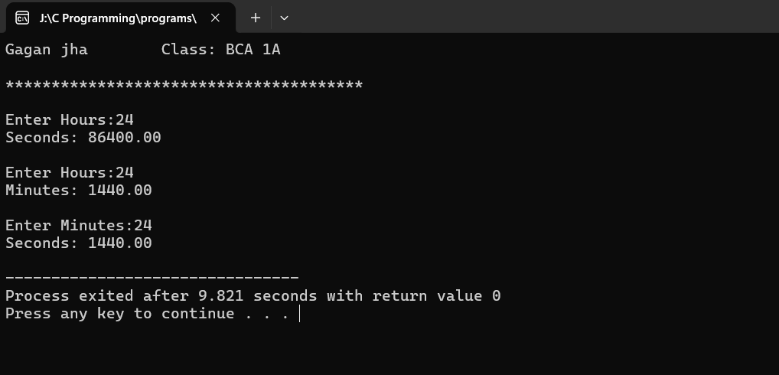

**12. To find area and perimeter of rectangle. Read  input from user**

#include<stdio.h>

int main() {

printf("Gagan jha \t Class: BCA 1A\n");

printf("\n***************************************\n\n");

float l,b,area,per;

printf("Enter Length:");

scanf("%f", &l);

printf("Enter Breadth:");

scanf("%f", &b);

area = l*b;

per = 2*(l+b);

printf("\nArea of Rectangle = %.2f\n", area);

printf("Perimerter: %.2f", per);

return 0;

}

**OUTPUT**

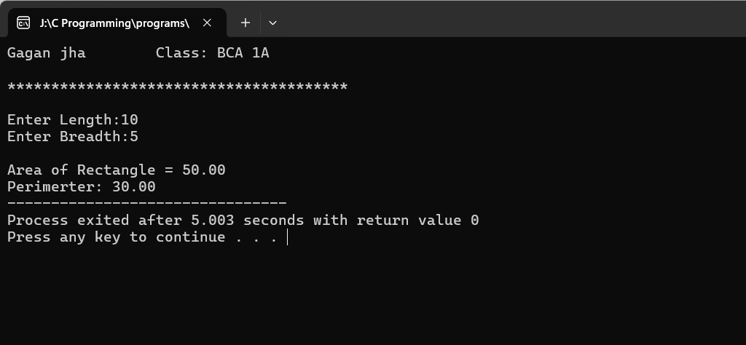

**13. To print circumference and area of circle. Read  input from user**

#include<stdio.h>

int main()

{

printf("Gagan jha \t Class: BCA 1A\n");

printf("\n***************************************\n\n");

float r, area, c;

printf("Enter Radius:");

scanf("%f", &r);

area = 3.14*r*r;

c = 2*3.14*r;

printf("Area of Circle = %.2f\n", area);

printf("Circumference = %.2f\n", c);

return 0;

}

**OUTPUT**

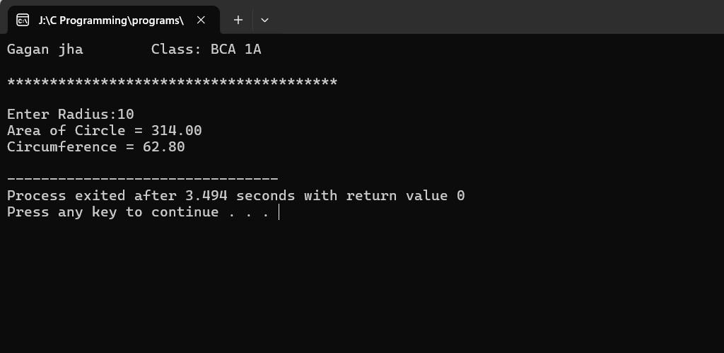

**14. To apply mathematical operation on ASCII value  of character variables**

#include<stdio.h>

int main() {

  printf("Gagan jha \t Class: BCA 1A\n");

 printf("\n***************************************\n\n");

 char a,b;

 float sum,dif,prod,quotient;

 printf("Enter 1st character:");

 scanf(" %c", &a);

 printf("Enter 2nd character:");

 scanf(" %c", &b);

 sum = a + b;

 dif = a - b;

 prod = a * b;

 quotient = a / b;

 printf("\nSum: %f\n", sum);

 printf("Difference: %f\n", dif);

 printf("Product: %f\n", prod);

 printf("Quotient: %f\n", quotient);

 return 0;

}

**OUTPUT**

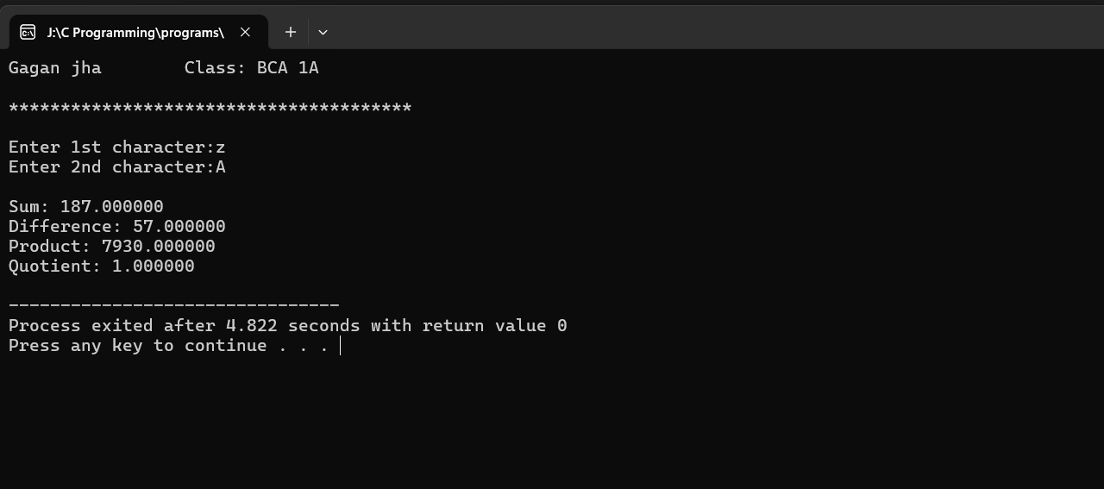

**15. Mathematical operation on character to get other  character**

#include <stdio.h>

int main() {

printf("Gagan jha \t Class: BCA 1A\n");

printf("\n***************************************\n\n");

char originalChar = 'D';

int asciiValue = (int)originalChar;

int newAsciiValue = asciiValue + 5;

char newChar = (char)newAsciiValue;

printf("Original character: %c\n", originalChar);

printf("New character after adding 5: %c\n", newChar);

return 0;

}

**OUTPUT**

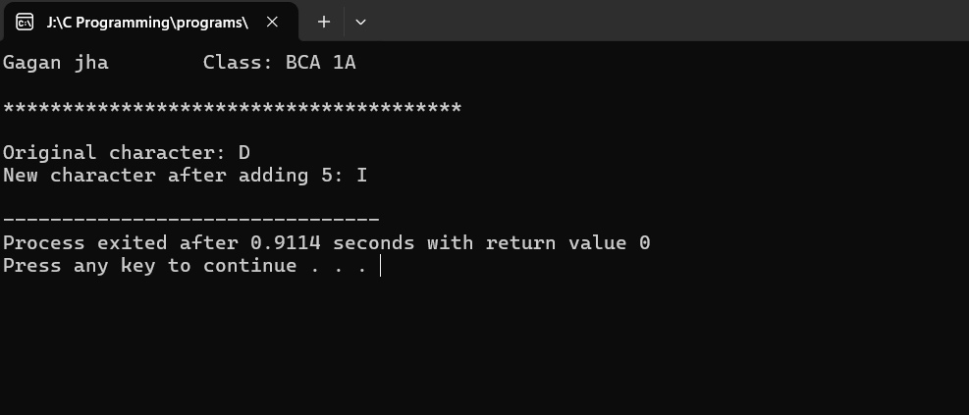

**16. WAP to read from user the values for 3 products (item  no, quantity, price).Find the total bill value and display.  Also, allow a discount of 10% on the total bill and  display net bill value**

#include <stdio.h>

int main(){

 printf("Gagan jha \t Class: BCA 1A\n");

 printf("\n***************************************\n\n");

int item_no, quantity;

float price;

printf("Enter the item number: ");

scanf("%d", &item_no);

printf("Enter the quantity: ");

scanf("%d", &quantity);

printf("Enter the price (in rupees): ");

scanf("%f", &price);

float total_bill = quantity * price;

printf("\nTotal Bill is %.2f\n", total_bill);

float discount = ((total_bill)/100)*10;

float net_bill = total_bill - discount;

printf("Net Bill is %.2f", net_bill);

return 0;

}

**OUTPUT**

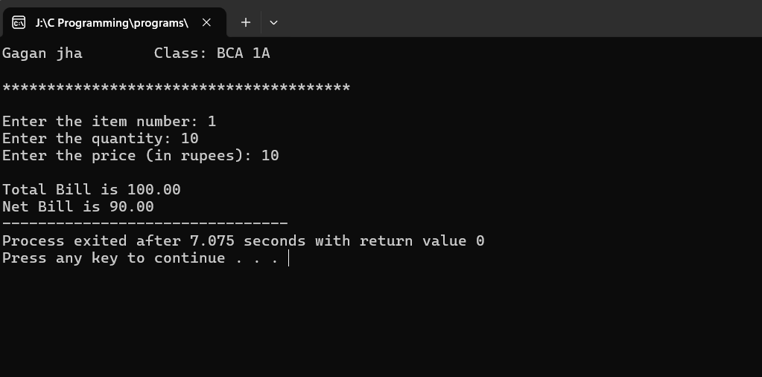

**17. To find maximum of two numbers by using  Conditional operator**

#include <stdio.h>

int main(){

 printf("Gagan jha \t Class: BCA 1A\n");

 printf("\n***************************************\nn");

int num1, num2, max;

 printf("Enter two numbers:");

 scanf("%d %d", &num1, &num2);

 max = (num1>num2)?num1:num2;

 printf("Maximum of %d and %d is %d\n", num1, num2, max);

 return 0;

}

**OUTPUT**

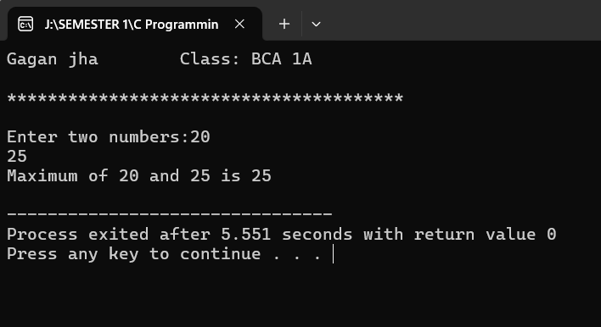

**18. To find maximum of three numbers using Conditional  operator**

#include <stdio.h>

int main(){

 printf("Gagan jha \t Class: BCA 1A\n");

 printf("\n***************************************\n\n");

 int num1, num2, num3, max;

 printf("Enter three numbers:\n");

 scanf("%d %d %d", &num1, &num2, &num3);

 max = (num1>num2 && num1>num3)?num1:(num2>num3)?num2:num3;  printf("Maximum of %d, %d and %d is %d\n", num1, num2, num3, max);

 return 0;

}

**OUTPUT**

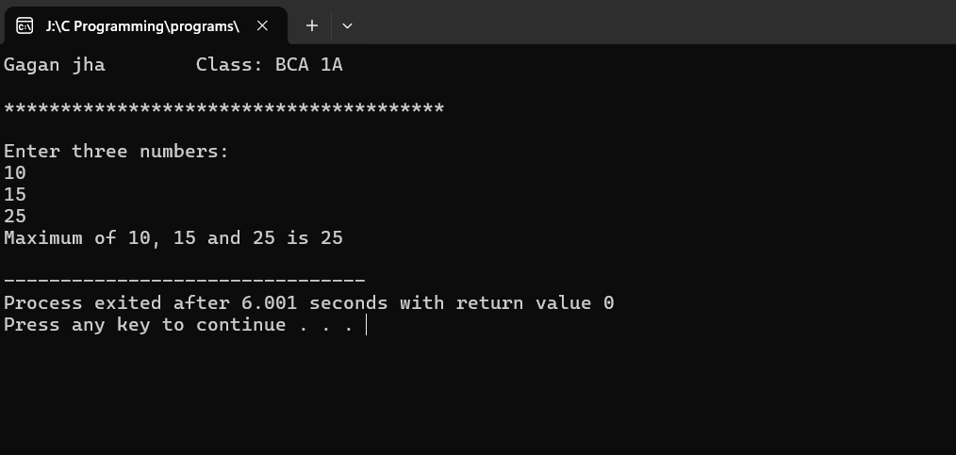

**19. To find maximum of two numbers by using if else  statement**

#include <stdio.h>

int main(){

 printf("Gagan jha \t Class: BCA 1A\n");

 printf("\n***************************************\n\n");

int num1, num2;

printf("Enter two numbers:\n");

scanf("%d %d", &num1, &num2);

if(num1>num2)

printf("Higher Number is %d", num1);

else

printf("Higher Number is %d", num2);

return 0;

}

**OUTPUT**

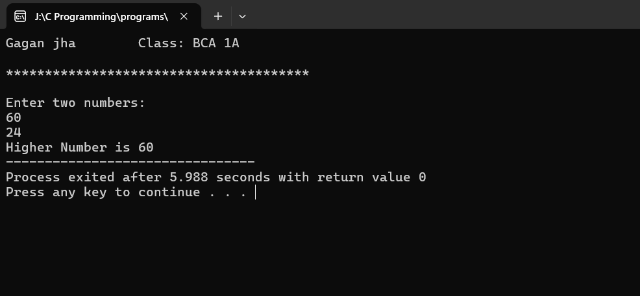

**20. To find maximum of three numbers by if else if  statement**

#include <stdio.h>

int main(){

printf("Gagan jha \t Class: BCA 1A\n");

printf("\n***************************************\n\n");

int num1, num2, num3, maximum;

printf("Enter three different numbers:\n");

scanf("%d %d %d", &num1, &num2, &num3);

if(num1>num2 && num1>num3)

maximum = num1;

else if(num2>num1 && num2>num3)

maximum = num2;

else

maximum = num3;

printf("Maximum of three number is %d", maximum);

return 0;

}

**OUTPUT**

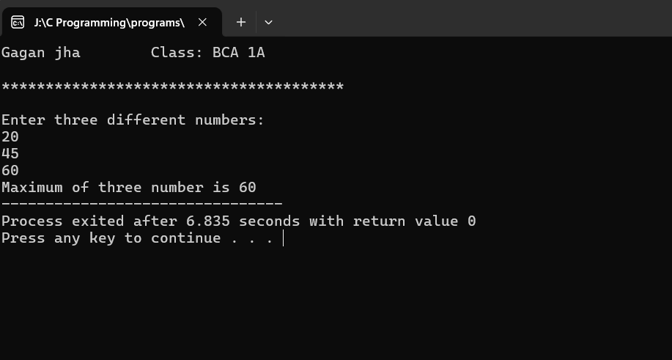

**21. To find grades on the basis of marks, using if-else and  relational operators**

**Average marks Grade**

**80 to 100 Honours**

**60 to 79 First Division**

**50 to 59 Second Division**

**40 to 49 Third Division**

**to 39 Fail**

#include <stdio.h>

int main() {

 printf("Gagan jha \t Class: BCA 1A\n");

 printf("\n***************************************\n\n");

 int marks;

 printf("Enter the marks: ");

 scanf("%d", &marks);

 if (marks >= 80 && marks <= 100) {

 printf("You got honours\n");

 } else if (marks >= 60 && marks < 80) {

 printf("You got First Division\n");

 } else if (marks >= 50 && marks < 60) {

 printf("You got Second Division\n");

 } else if (marks >= 40 && marks < 50) {

 printf("You got Third Division\n");

 } else {

 printf("Sorry, you have to reappear\n");

 }

 return 0;

}

**OUTPUT**

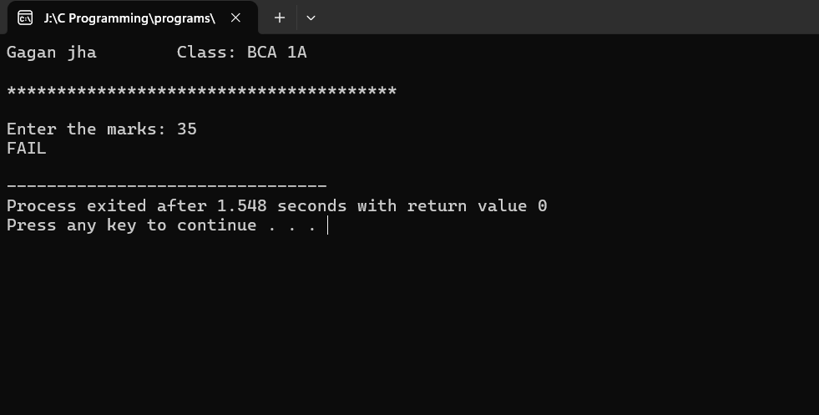

**22. To find electricity charges based on consumption  Consumption Units Rate of Charge**

**0 — 200 Rs. 0.50 per unit**

**201 — 400 Rs. 100 plus Rs. 0.65 per unit excess of 200  401 — 600 Rs. 230 plus Rs. 0.80 per unit excess of 400  601 and above Rs. 390 plus Rs. 1.00 per unit excess of  600**

#include <stdio.h>

int main(){

 printf("Gagan jha \t Class: BCA 1A\n");

 printf("\n***************************************\n\n");

int units;

 float charge = 0;

 printf("Enter electricity consumption in units: ");

 scanf("%d", &units);

 if (units <= 200) {

 charge = units * 0.50;

 } else if (units <= 400) {

 charge = 100 + (units - 200) * 0.65;

 } else if (units <= 600) {

 charge = 230 + (units - 400) * 0.80;

 } else {

 charge = 390 + (units - 600) * 1.00;

 }

 printf("Total electricity charge: Rs. %.2f\n", charge);

 return 0;

}

**OUTPUT**

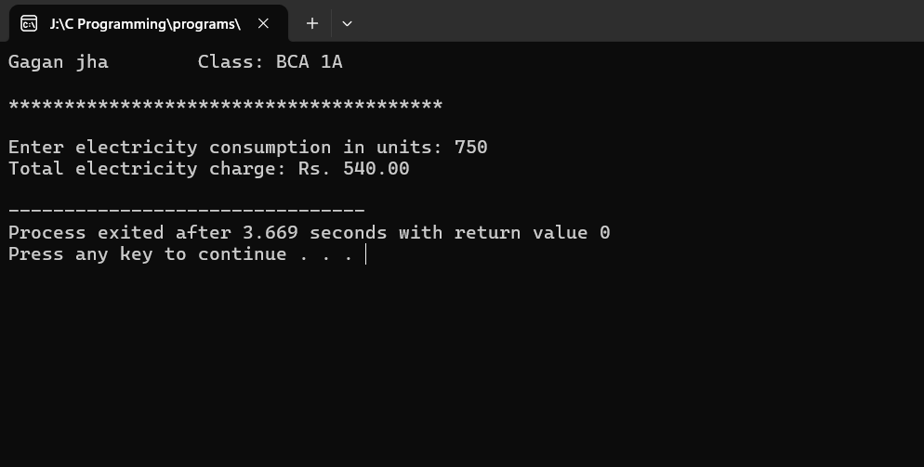

**23. WAP to read two integers and an operator (+,- * /,%).  Use switch-case statement to get result of operator on  two integers.**

#include <stdio.h>

int main() {

 printf("Gagan jha \t Class: BCA 1A\n");

 printf("\n***************************************\n\n");

int a, b, c;

char op;

printf("Enter two numbers:\n");

scanf("%d %d", &a, &b);

getchar();

printf("Enter an operator among them(+,-,*,%,/):");

scanf("%c", &op);

switch(op){

case '+':

c=a+b;

printf("Sum of %d and %d is %d", a, b, c);

break;

case '-':

c=a-b;

printf("Difference of %d and %d is %d", a, b, c);

break;

case '*':

c=a*b;

printf("Multiplication of %d and %d is %d", a, b, c);

break;

case '%':

c=a%b;

printf("Modulus of %d and %d is %d", a, b, c);

break;

case '/':

if(b==0){

printf("Invalid Output: Division by 0");

}

else {

c=a/b;

printf("Division of %d and %d is %d", a, b, c);

}

break;

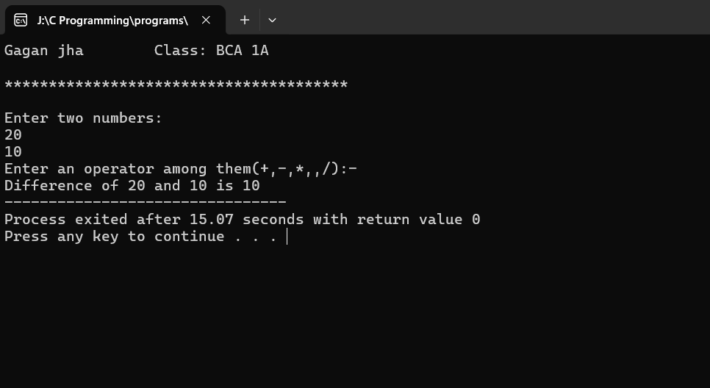default:

printf("Invalid input");

}

return 0;

}

**OUTPUT:-**

**24. To find nature of roots of quadratic equations**

#include <stdio.h>

int main() {

 printf("Gagan jha \t Class: BCA 1A\n");

 printf("\n***************************************\n\n");

 float a, b, c, discriminant;

 printf("Enter coefficients a, b and c: ");

 scanf("%f %f %f", &a, &b, &c);

 discriminant = b * b - 4 * a * c;

 if (discriminant > 0) {

 printf("The roots are real and distinct.\n");

 }

 else if (discriminant == 0) {

 printf("The roots are real and equal.\n");

 }

 else {

 printf("The roots are complex and imaginary.\n");

 }

 return 0;

}

**OUTPUT**

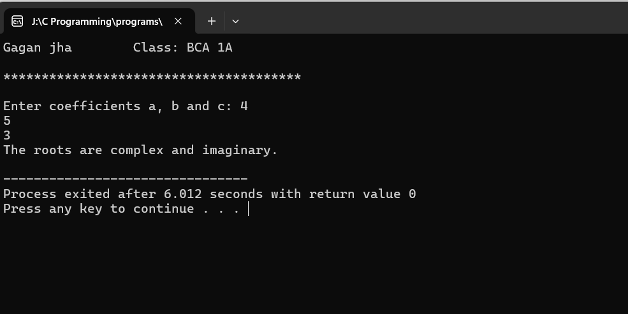

**25. WAP to print natural numbers till n using while loop.  Also print reverse counting from m to l. Get m,n from  user at runtime**

#include <stdio.h>

int main() {

printf("Gagan jha \t Class: BCA 1A\n");

printf("\n***************************************\n\n");

int a, b;

printf("Enter the first number (upper limit for counting up): ");

scanf("%d", &a);

printf("Enter the second number (upper limit for counting down): ");

scanf("%d", &b);

printf("\nCounting up from 1 to %d:\n", a);

int i = 1;

while (i <= a) {

printf("\t%d", i);

i++;

}

printf("\n\nCounting down from %d to 1:\n", b);

while (b >= 1) {

printf("\t%d", b);

b--;

}

return 0;

}

**OUTPUT**

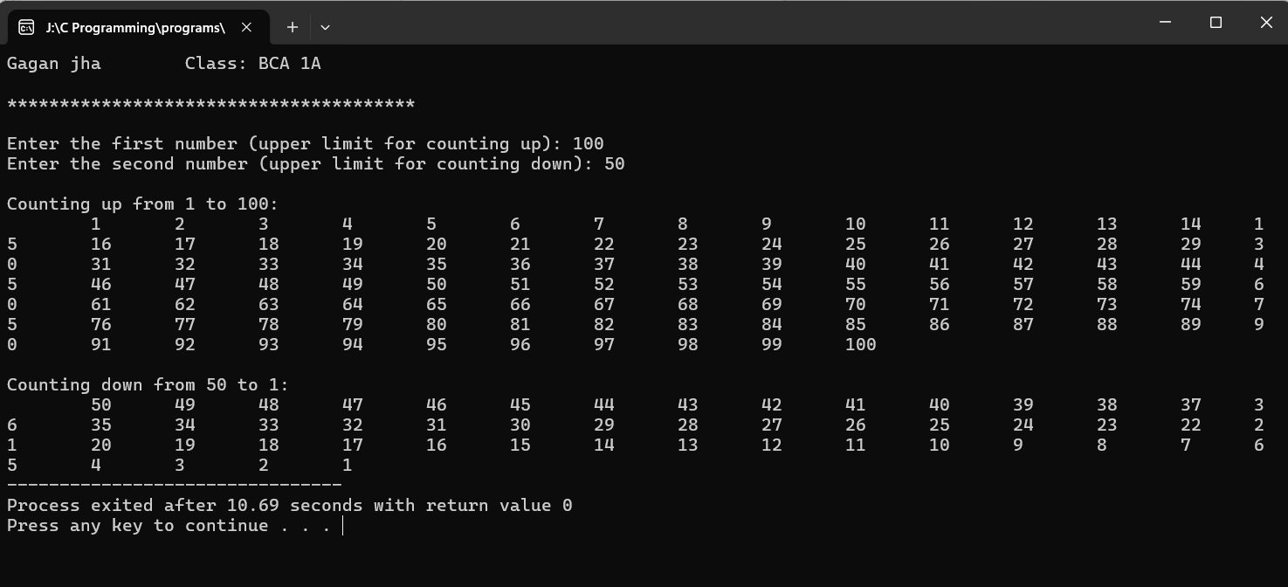

**26. WAP to compute x^n using while statement**

#include <stdio.h>

int main() {

 printf("Gagan jha \t Class: BCA 1A\n");

 printf("\n***************************************\n\n");

 int x, p,n=1;

 printf("Enter the base (X): ");

 scanf("%d", &x);

 printf("Enter the exponent (p): ");

 scanf("%d", &p);

 int i = 1;

 while(i<=p){

 n *= x;

 printf("%d^%d = %d\n", x, i, n);

 i++;

}

 return 0;

}

**OUTPUT**

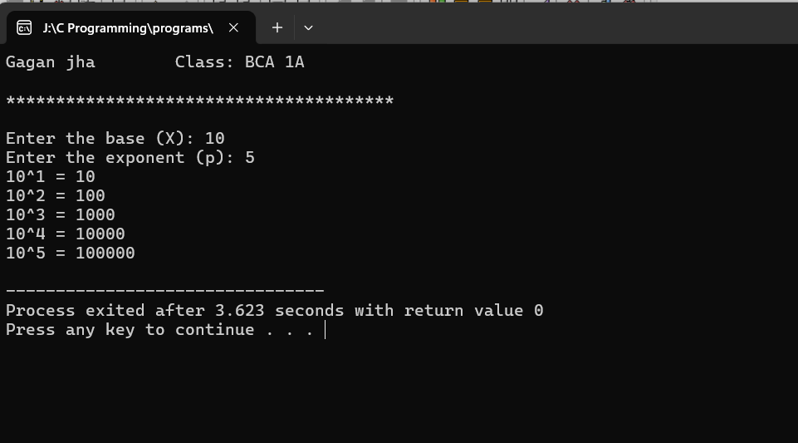

**27. WAP to generate multiplication tables using nested  do-while statements**

#include <stdio.h>

int main(){

printf("Gagan jha \t Class: BCA 1A\n");

printf("\n***************************************\n\n");

int x;

printf("Enter a number: ");

scanf("%d", &x);

int i=1;

do{

printf("%d X %d = %d\n", x, i, x*i);

i++;

}while(i<=10);

return 0;

}

**OUTPUT**

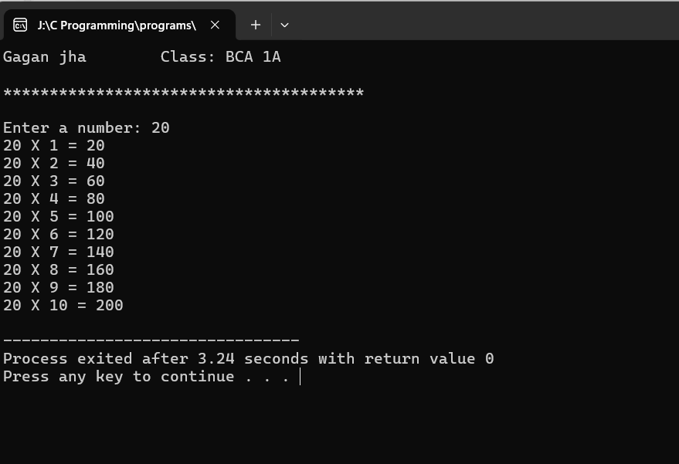

**28. WAP to print following patterns: triangle of '*'  triangle of digits**

#include <stdio.h>

int main(){

 printf("Gagan jha \t Class: BCA 1A\n");

 printf("\n***************************************\n\n");

int n, i, j, p, q;

printf("Enter a number: ");

scanf("%d", &n);

for(i=1; i<=n; i++){

for(j=1; j<=i; j++){

printf("* ", j);

}

printf("\n");

}

for(p=1; p<=n; p++){

for(q=1; q<=p; q++){

printf("%d ", q);

}

printf("\n");

}

return 0;

}

**OUTPUT**

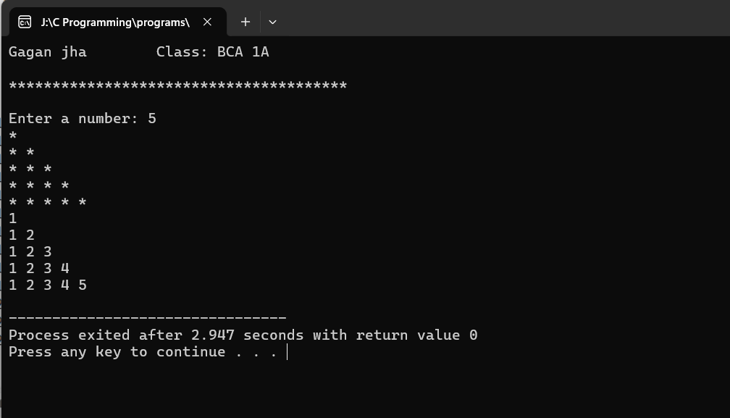

**29. To read an integer and print sum of its digits using  while loop. Construct and print reverse on n-digit  number using do-while loop**

#include <stdio.h>

int main() {

printf("Gagan jha \t Class: BCA 1A\n");

printf("\n***************************************\n\n");

int num, digitSum = 0, tempNum, digit;

printf("Enter a number: ");

scanf("%d", &num);

tempNum = num;

while (tempNum != 0) {

digitSum += tempNum % 10;

tempNum /= 10;

}

printf("Sum of digits: %d\n", digitSum);

printf("Digits of the number (in reverse order): ");

tempNum = num;

do {

digit = tempNum % 10;

printf("%d", digit);

tempNum /= 10;

} while (tempNum != 0);

printf("\n");

return 0;

}

**OUTPUT**

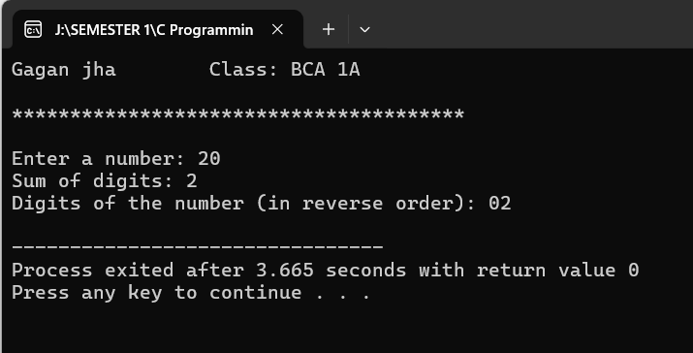

**30. To determine if given number is prune or composite**

#include <stdio.h>

int main(){

printf("Gagan jha \t Class: BCA 1A\n");

printf("\n***************************************\n\n");

int a, i, count=0;

printf("Enter a number: ");

scanf("%d", &a);

for(i=2; i<=a/2; i++){

if(a%i == 0){;

count++;

}

}

if(count == 0)

printf("Number is Prime");

else

printf("Number is composite");

return 0;

}

**OUTPUT**

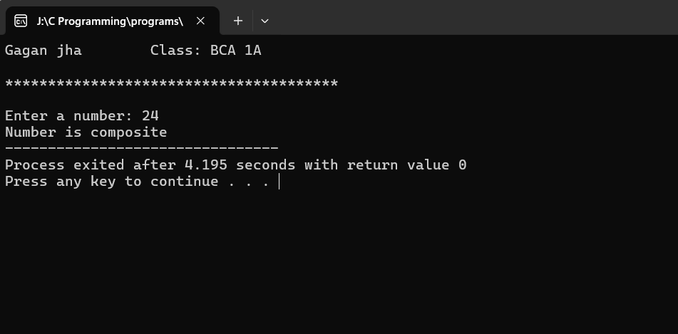

**31. To print sum of first n odd natural numbers**

#include <stdio.h>

int main(){

 printf("Gagan jha \t Class: BCA 1A\n");

 printf("\n***************************************\n\n");

int n, i, sum=0;

printf("Enter a number: ");

scanf("%d", &n);

for(i=1; i<=n; i++){

int odd_num = 2*i-1;

sum += odd_num;

printf("%d ", odd_num);

}

printf("\nSum of first %d odd number is %d", i-1, sum);

return 0;

 }

**OUTPUT**

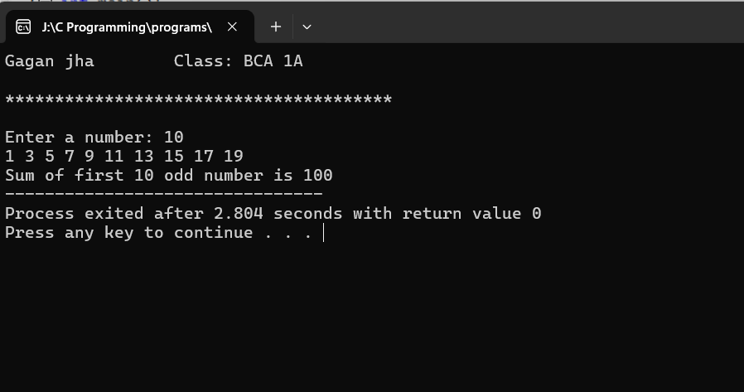

**32. To print sum of series: 1+1/2+.....+1/n** #include <stdio.h>

int main(){

 printf("Gagan jha \t Class: BCA 1A\n");

 printf("\n***************************************\n\n");

int n, i;

float sum=0;

printf("Enter a number: ");

scanf("%d", &n);

for(i=1; i<=n; i++){

sum += (float)1/i;

printf("1/%d ", i);

}

printf("\nSum of series is %f", sum);

return 0;

}

**OUTPUT**

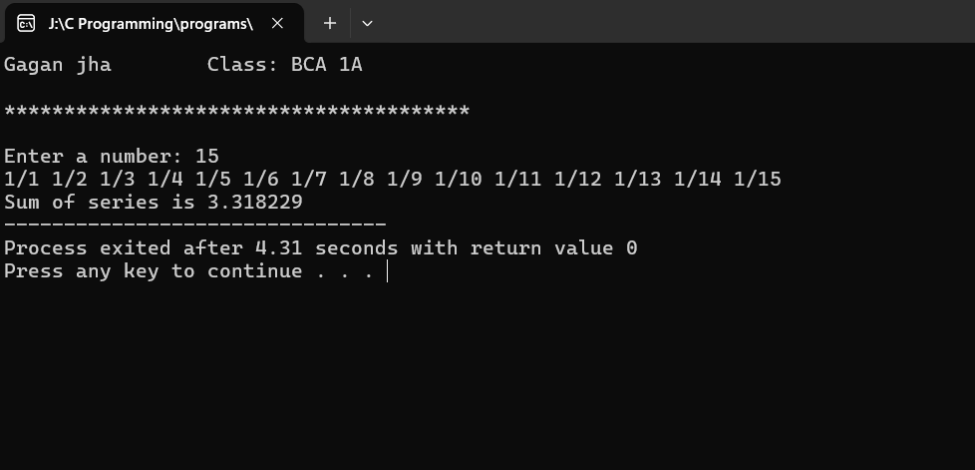

**33. WAP to implement a function printline(int n,char ch) to print ‘ch’ n-times.**

#include <stdio.h>

void printline(int n, char ch) {

for (int i = 0; i < n; i++) {

printf("%c", ch);

}

printf("\n");

}

int main() {

printf("Gagan jha \t Class: BCA 1A\n");

printf("\n***************************************\n\n");

int n;

char ch;

printf("Enter the number of times to print the character: ");

scanf("%d", &n);

printf("Enter the character: ");

scanf(" %c", &ch);

printline(n, ch);

return 0;

} **OUTPUT**

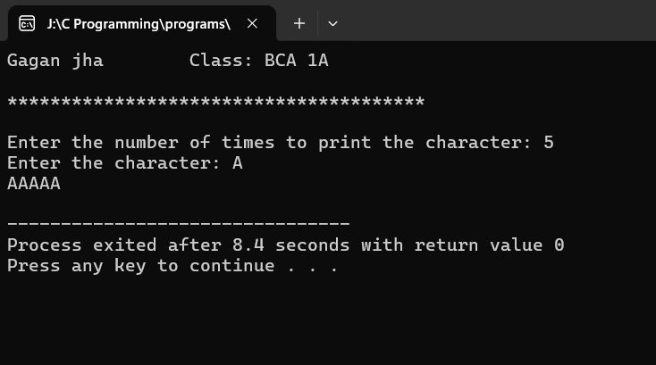

**34. program to find simple interest in a Function. Create function with arguments and return type.**

#include <stdio.h>

float simple_interest(float principal, float rate, float time) {

float interest;

interest = (principal * rate * time) / 100;

return interest;

}

int main() {

printf("Gagan jha \t Class: BCA 1A\n");

printf("\n***************************************\n\n");

float principal, rate, time, interest;

printf("Enter principal amount: ");

scanf("%f", &principal);

printf("Enter rate of interest: ");

scanf("%f", &rate);

printf("Enter time period (in years): ");

scanf("%f", &time);

interest = simple_interest(principal, rate, time);

printf("Simple interest: %.2f\n", interest);

return 0;

}

**OUTPUT**

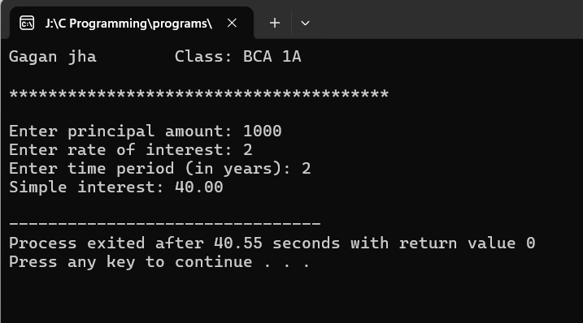

**35. program to swap two numbers using functions (call by reference)**

#include <stdio.h>

void swap(int *x, int *y) {

int temp;

temp = *x;

*x = *y;

*y = temp;

}

int main() {

printf("Gagan jha \t Class: BCA 1A\n");

printf("\n***************************************\n\n");

int a, b;

printf("Enter two numbers: ");

scanf("%d %d", &a, &b);

printf("Before swapping: a = %d, b = %d\n", a, b);

swap(&a, &b);

printf("After swapping: a = %d, b = %d\n", a, b);

return 0;

}

**OUTPUT**

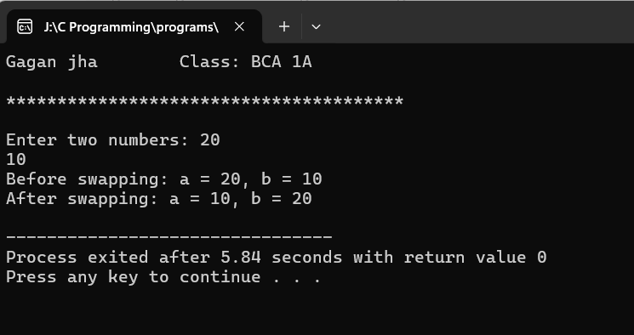

**36. program to find factorial of a number using function and return its value in the calling function**

#include <stdio.h>

int factorial(int n) {

if (n == 0) {

return 1;

} else {

return n * factorial(n - 1);

}

}

int main() {

printf("Gagan jha \t Class: BCA 1A\n");

printf("\n***************************************\n\n");

int num, result;

printf("Enter a non-negative integer: ");

scanf("%d", &num);

if (num < 0) {

printf("Factorial is not defined for negative numbers.\n");

} else {

result = factorial(num);

printf("Factorial of %d is %d\n", num, result);

} return 0;}

**OUTPUT**

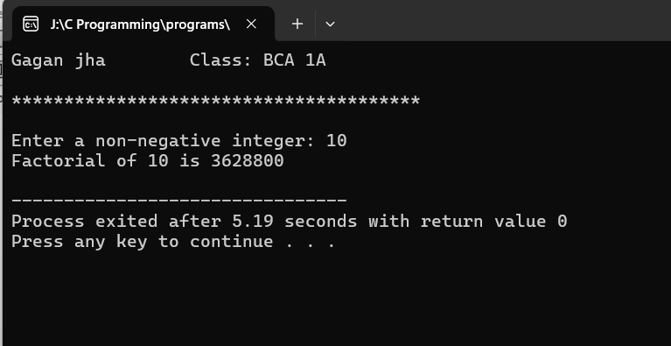

**37. Program to find factorial of a number using recursion**

#include <stdio.h>

int factorial(int n) {

if (n == 0) {

return 1;

} else {

return n * factorial(n - 1);

}

}

int main() {

printf("Gagan jha \t Class: BCA 1A\n");

printf("\n***************************************\n\n");

int num, result;

printf("Enter a non-negative integer: ");

scanf("%d", &num);

if (num < 0) {

printf("Factorial is not defined for negative numbers.\n");

} else {

result = factorial(num);

printf("Factorial of %d is %d\n", num, result);

}

return 0;

} **OUTPUT**

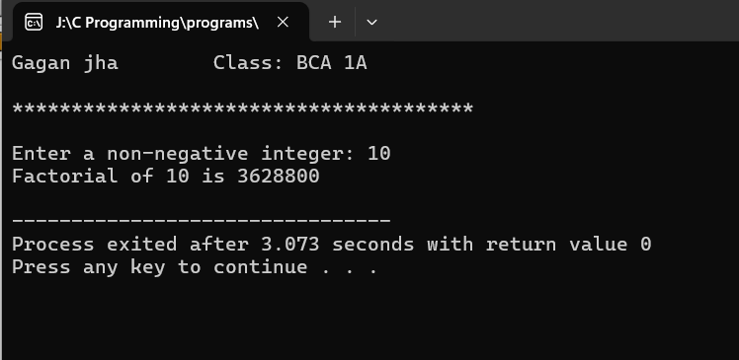

**38. Program to display usage of static variables**

#include <stdio.h>

int count = 0; // Static variable initialized to 0

void increment() {

count++; // Increment the static variable

}

int main() {

printf("Gagan jha \t Class: BCA 1A\n");

printf("\n***************************************\n\n");

increment();

printf("Count after first increment: %d\n", count);

increment();

printf("Count after second increment: %d\n", count);

return 0;

}

**OUTPUT**

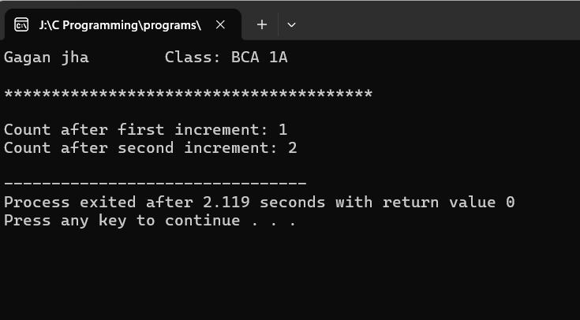

**39. Program to display Fibonacci series using recursion**

#include <stdio.h>

int fibonacci(int n) {

if (n <= 1) {

return n;

} else {

return fibonacci(n-1) + fibonacci(n-2);

}

}

int main() {

printf("Gagan jha \t Class: BCA 1A\n");

printf("\n***************************************\n\n");

int n, i;

printf("Enter the number of terms: ");

scanf("%d", &n);

printf("Fibonacci Series:\n");

for (i = 0; i < n; ++i) {

printf("%d ", fibonacci(i));

}

return 0;

}

**OUTPUT**

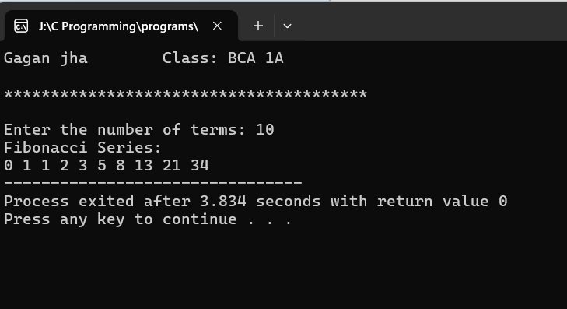

**40. Program to find all 3-digit Armstrong numbers**

#include <stdio.h>

int main() {

printf("Gagan jha \t Class: BCA 1A\n");

printf("\n***************************************\n\n");

int num, originalNum, remainder, result = 0;

printf("Armstrong Numbers between 100 and 999:\n");

for (num = 100; num <= 999; num++) {

originalNum = num;

while (originalNum != 0) {

remainder = originalNum % 10;

result += remainder * remainder * remainder;

originalNum /= 10;

}

if (result == num) {

printf("%d\n", num);

}

result = 0; // Reset result for the next number

}

return 0;

}

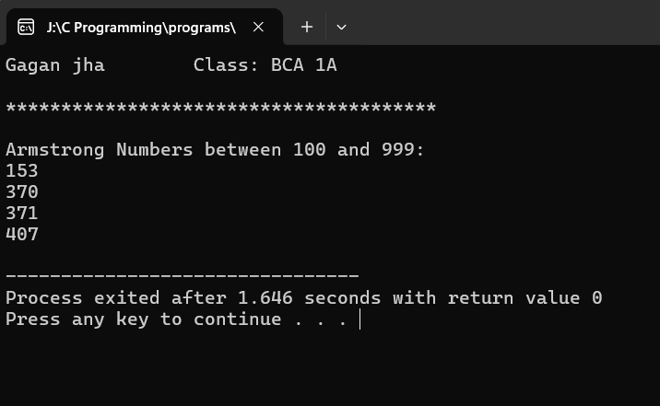 **OUTPUT**

**41. To read a number and check if it is odd or even (if-else)**

#include <stdio.h>

int main() {

printf("Gagan jha \t Class: BCA 1A\n");

printf("\n***************************************\n\n");

int number;

printf("Enter a number: ");

scanf("%d", &number);

if (number % 2 == 0) {

printf("%d is even.\n", number);

} else {

printf("%d is odd.\n", number);

}

return 0;

}

**OUTPUT**

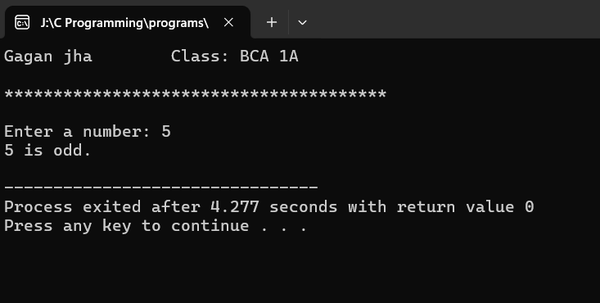

**42. To check whether the given 5 digit number is a palindrome or not**

#include <stdio.h>

int main() {

printf("Gagan jha \t Class: BCA 1A\n");

printf("\n***************************************\n\n");

int num, reversed = 0, original;

printf("Enter a 5-digit number: ");

scanf("%d", &num);

if (num < 10000 || num > 99999) {

printf("Please enter a 5-digit number.\n");

return 1;

}

original = num;

while (num != 0) {

reversed = reversed * 10 + num % 10;

num /= 10;

}

if (original == reversed) {

printf("%d is a palindrome.\n", original);

} else {

printf("%d is not a palindrome.\n", original);

} return 0; }

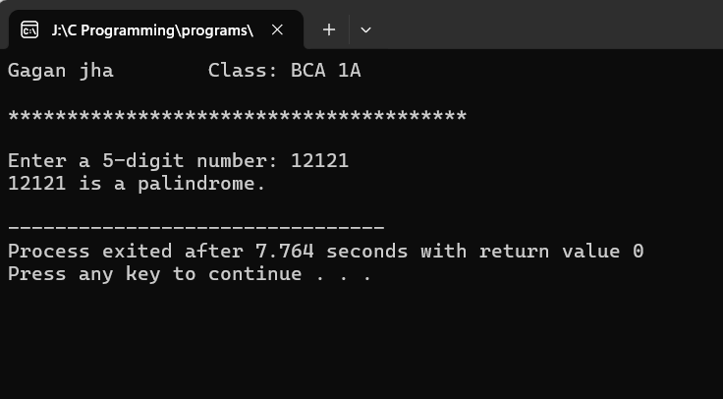**OUTPUT**

**43. Program to Show sum of n elements of array &show the average.**

#include <stdio.h>

int main() {

printf("Gagan jha \t Class: BCA 1A\n");

printf("\n***************************************\n\n");

int n, i, sum = 0;

float average;

printf("Enter the number of elements: ");

scanf("%d", &n);

int arr[n];

printf("Enter %d elements:\n", n);

for (i = 0; i < n; i++) {

scanf("%d", &arr[i]);

sum += arr[i];

}

average = (float)sum / n;

printf("Sum of the elements: %d\n", sum);

printf("Average of the elements: %.2f\n", average);

return 0;

}

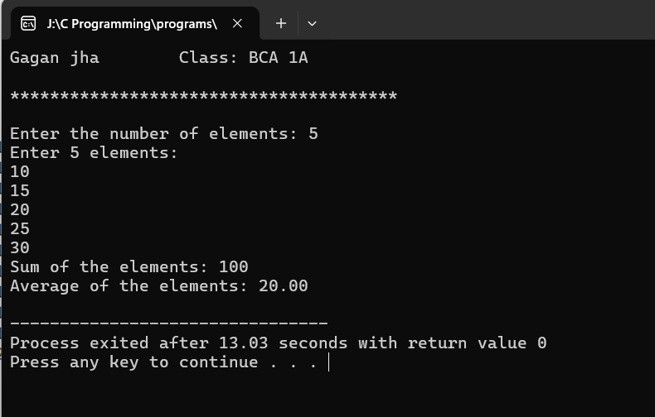**OUTPUT**

**44. Program to find the maximum and minimum integer in an array using functions**

#include <stdio.h>

int findMax(int arr[], int n) {

int max = arr[0];

for (int i = 1; i < n; i++) {

if (arr[i] > max) {

max = arr[i];

}

}

return max;

}

int findMin(int arr[], int n) {

int min = arr[0];

for (int i = 1; i < n; i++) {

if (arr[i] < min) {

min = arr[i];

}

}

return min;

}

int main() {

printf("Gagan jha \t Class: BCA 1A\n");

printf("\n***************************************\n\n");

int n;

printf("Enter the number of elements in the array: ");

scanf("%d", &n);

int arr[n];

printf("Enter the elements of the array:\n");

for (int i = 0; i < n; i++) {

scanf("%d", &arr[i]);

}

int max = findMax(arr, n);

int min = findMin(arr, n);

printf("Maximum element: %d\n", max);

printf("Minimum element: %d\n", min);

return 0;

}

**OUTPUT**

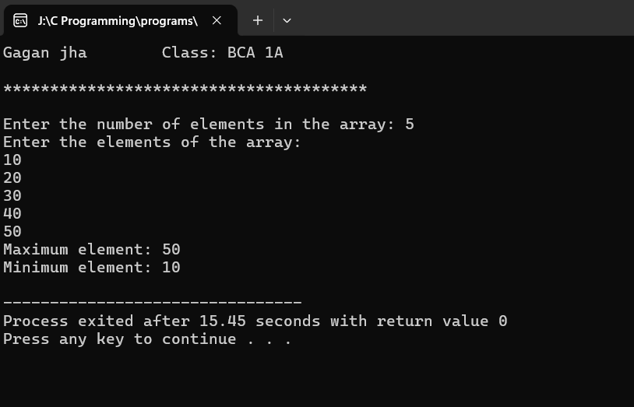

**45 Program to perform Linear search on an array.**

#include <stdio.h>

int linearSearch(int arr[], int n, int x) {

int i;

for (i = 0; i < n; i++) {

if (arr[i] == x) {

return i;

}

} return -1;

}

int main() {

printf("Gagan jha \t Class: BCA 1A\n");

printf("\n***************************************\n\n");

int arr[] = {10, 20, 30, 40, 50};

int n = sizeof(arr) / sizeof(arr[0]);

int x;

printf("Enter the element to search: ");

scanf("%d", &x);

int result = linearSearch(arr, n, x);

if (result != -1) {

printf("Element found at index %d\n", result);

} else {

printf("Element not found\n");

} return 0; }

**OUTPUT**

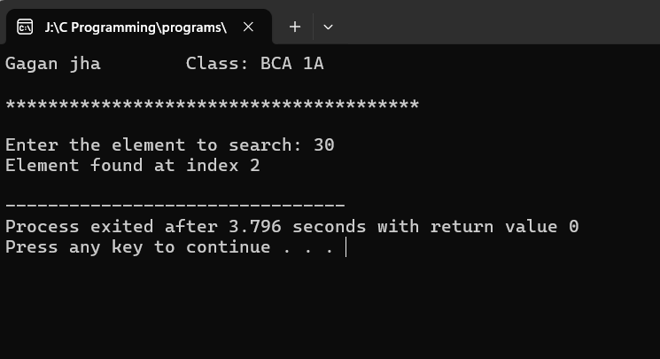

**46 Program to generate reverse array for a given array.**

#include <stdio.h>

void reverseArray(int arr[], int size) {

int start = 0;

int end = size - 1;

while (start < end) {

// Swap elements at start and end indices

int temp = arr[start];

arr[start] = arr[end];

arr[end] = temp;

// Update indices

start++;

end--;

}

}

int main() {

printf("Gagan jha \t Class: BCA 1A\n");

printf("\n***************************************\n\n");

int arr[] = {1, 2, 3, 4, 5};

int size = sizeof(arr) / sizeof(arr[0]);

printf("Original array: ");

for (int i = 0; i < size; i++) {

printf("%d ", arr[i]);

}

printf("\n");

reverseArray(arr, size);

printf("Reversed array: ");

for (int i = 0; i < size; i++) {

printf("%d ", arr[i]);

}

printf("\n");

return 0;

}

**OUTPUT**

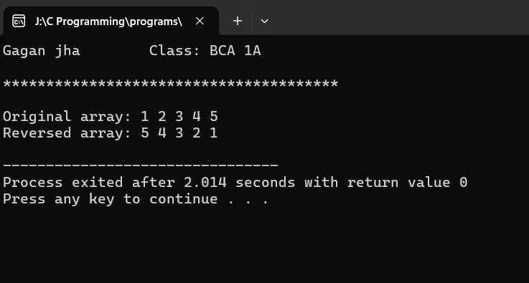

**47 Program to perform Matrix Operations (switch-case): Addition, Subtraction, Multiplication and Transpose**

#include <stdio.h>

int main() {

printf("Gagan jha \t Class: BCA 1A\n");

printf("\n***************************************\n\n");

int choice, rows, cols, i, j;

printf("Enter the number of rows and columns of the matrices: ");

scanf("%d %d", &rows, &cols);

int matrix1[rows][cols], matrix2[rows][cols], result[rows][cols];

printf("Enter elements of matrix 1:\n");

for (i = 0; i < rows; i++) {

for (j = 0; j < cols; j++) {

scanf("%d", &matrix1[i][j]);

}

}

printf("Enter elements of matrix 2:\n");

for (i = 0; i < rows; i++) {

for (j = 0; j < cols; j++) {

scanf("%d", &matrix2[i][j]);

}

}

printf("Choose an operation:\n");

printf("1. Addition\n");

printf("2. Subtraction\n");

printf("3. Multiplication\n");

printf("4. Transpose\n");

printf("Enter your choice: ");

scanf("%d", &choice);

switch (choice) {

case 1:

printf("Addition:\n");

for (i = 0; i < rows; i++) {

for (j = 0; j < cols; j++) {

result[i][j] = matrix1[i][j] + matrix2[i][j];

printf("%d ", result[i][j]);

}

printf("\n");

}

break;

case 2:

printf("Subtraction:\n");

for (i = 0; i < rows; i++) {

for (j = 0; j < cols; j++) {

result[i][j] = matrix1[i][j] - matrix2[i][j];

printf("%d ", result[i][j]);

}

printf("\n");

}

break;

case 3:

printf("Multiplication:\n");

for (i = 0; i < rows; i++) {

for (j = 0; j < cols; j++) {

result[i][j] = 0;

for (int k = 0; k < cols; k++) {

result[i][j] += matrix1[i][k] * matrix2[k][j];

}

printf("%d ", result[i][j]);

}

printf("\n");

}

break;

case 4:

printf("Transpose:\n");

for (i = 0; i < cols; i++) {

for (j = 0; j < rows; j++) {

result[i][j] = matrix1[j][i];

printf("%d ", result[i][j]);

}

printf("\n");

}

break;

default:

printf("Invalid choice!\n");

}

return 0;

}

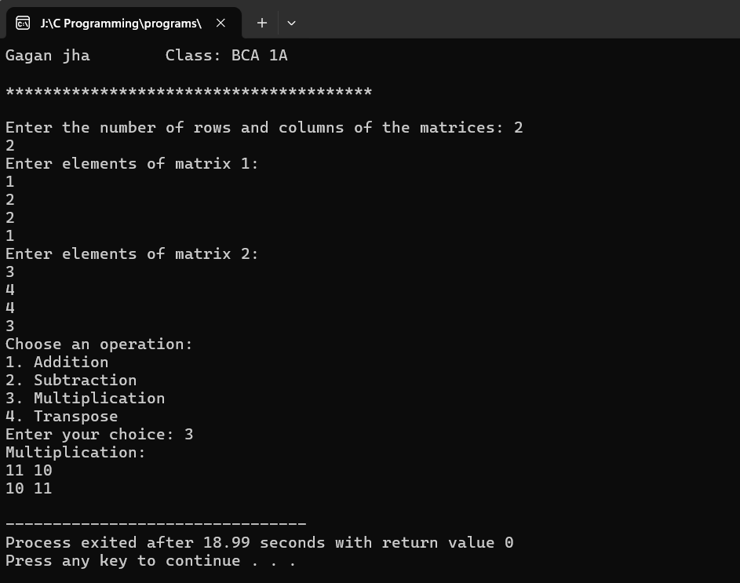**OUTPUT:**

**48 Program to read character array using getchar() in do-while loop and print it. Find its length and number of vowels (Case-sensitive)**

#include <stdio.h>

int main() {

printf("Gagan jha \t Class: BCA 1A\n");

printf("\n***************************************\n\n");

char ch;

int length = 0, vowelCount = 0;

printf("Enter characters (enter 'q' to quit):\n");

do {

ch = getchar();

if (ch != 'q') {

length++;

if (ch == 'a' || ch == 'e' || ch == 'i' || ch == 'o' || ch == 'u') {

vowelCount++;

}

}

} while (ch != 'q');

printf("\nLength of the string: %d\n", length);

printf("Number of vowels: %d\n", vowelCount);

return 0;

}

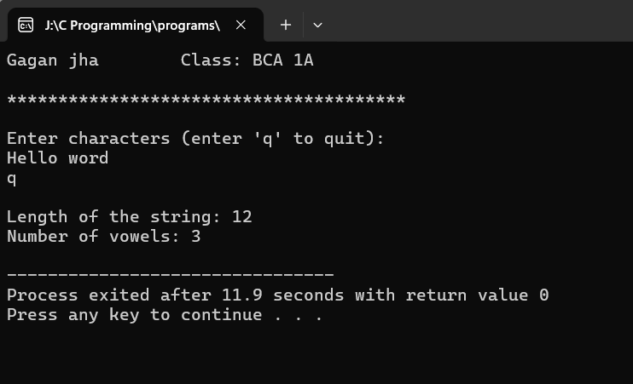**OUTPUT**

**49 Program to find reverse of a string (without inbuilt function.)**

#include <stdio.h>

void reverse_string(char *str) {

int length = 0;

int i, j;

// Calculate the length of the string

while (str[length] != '\0') {

length++;

}

// Swap characters from both ends of the string until they meet

for (i = 0, j = length - 1; i < j; i++, j--) {

char temp = str[i];

str[i] = str[j];

str[j] = temp;

}

}

int main() {

printf("Gagan jha \t Class: BCA 1A\n");

printf("\n***************************************\n\n");

char str[100];

printf("Enter a string: ");

fgets(str, sizeof(str), stdin);

reverse_string(str);

printf("Reversed string: %s", str);

return 0;

}

**OUTPUT**

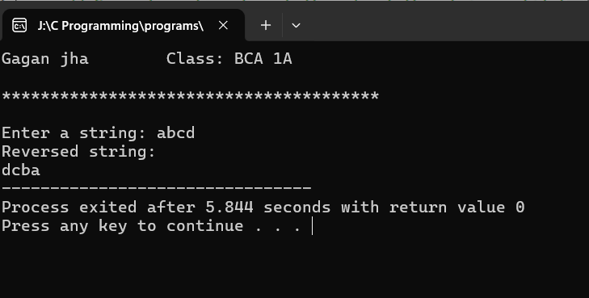

**50 Program to compare and concatenate two string (without  
inbuilt function)**

#include <stdio.h>

int compareStrings(char str1[], char str2[])

{

int i = 0;

while (str1[i] != '\0' && str2[i] != '\0') {

if (str1[i] < str2[i]) {

return -1; // str1 comes before str2

} else if (str1[i] > str2[i]) {

return 1; // str1 comes after str2

}

i++;

}

if (str1[i] == '\0' && str2[i] == '\0') {

return 0; // strings are equal

} else if (str1[i] == '\0') {

return -1; // str1 is shorter

} else {

return 1; // str1 is longer

}

}

void concatenateStrings(char str1[], char str2[]) {

int i = 0, j = 0;

while (str1[i] != '\0') {

i++;

}

while (str2[j] != '\0') {

str1[i++] = str2[j++];

}

str1[i] = '\0';

}

int main() {

printf("Gagan jha \t Class: BCA 1A\n");

printf("\n***************************************\n\n");

char str1[100], str2[100];

printf("Enter the first string: ");

scanf("%s", str1);

printf("Enter the second string: ");

scanf("%s", str2);

int result = compareStrings(str1, str2);

if (result < 0) {

printf("%s comes before %s\n", str1, str2);

} else if (result > 0) {

printf("%s comes after %s\n", str1, str2);

} else {

printf("The strings are equal\n");

}

concatenateStrings(str1, str2);

printf("Concatenated string: %s\n", str1);

return 0;

}

**OUTPUT**

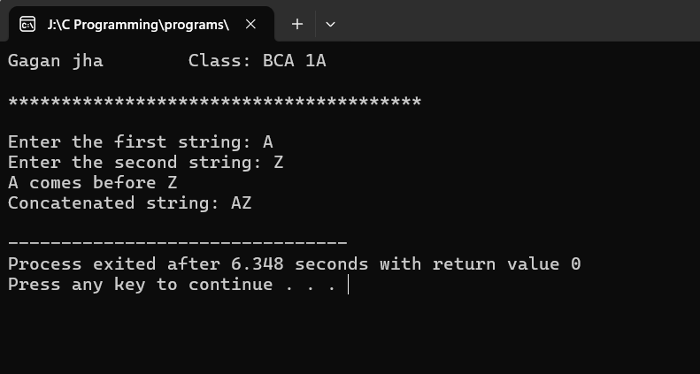

**51 Program to copy a string to another string (without inbuilt function.)**

#include <stdio.h>

int main() {

printf("Gagan jha \t Class: BCA 1A\n");

printf("\n***************************************\n\n");

char sourceString[100], targetString[100];

int i = 0;

printf("Enter the source string: ");

gets(sourceString);

while (sourceString[i] != '\0') {

targetString[i] = sourceString[i];

i++;

}

targetString[i] = '\0';

printf("Copied string: %s\n", targetString);

return 0;

}

**OUTPUT**

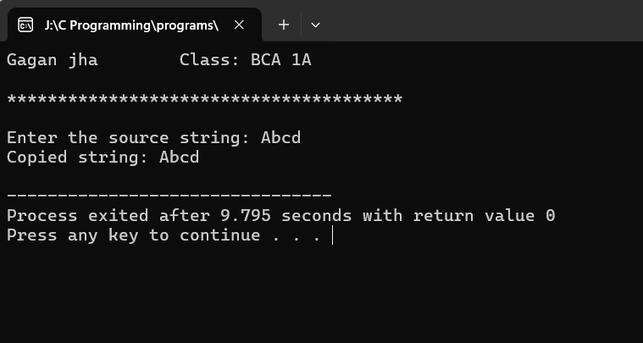

**52 Program to show the use of string function: strcpy(), strcat(), strcmp(), strlen().**

#include <stdio.h>

#include <string.h>

int main() {

printf("Gagan jha \t Class: BCA 1A\n");

printf("\n***************************************\n\n");

char str1[100], str2[100];

printf("Enter the first string: ");

scanf("%s", str1);

printf("Enter the second string: ");

scanf("%s", str2);

strcpy(str1, str2);

printf("After strcpy(): str1 = %s\n", str1);

strcat(str1, str2);

printf("After strcat(): str1 = %s\n", str1);

int result = strcmp(str1, str2);

if (result == 0) {

printf("str1 and str2 are equal.\n");

} else if (result < 0) {

printf("str1 is lexicographically less than str2.\n");

} else {

printf("str1 is lexicographically greater than str2.\n");

}

int length = strlen(str1);

printf("Length of str1: %d\n", length);

return 0;

}

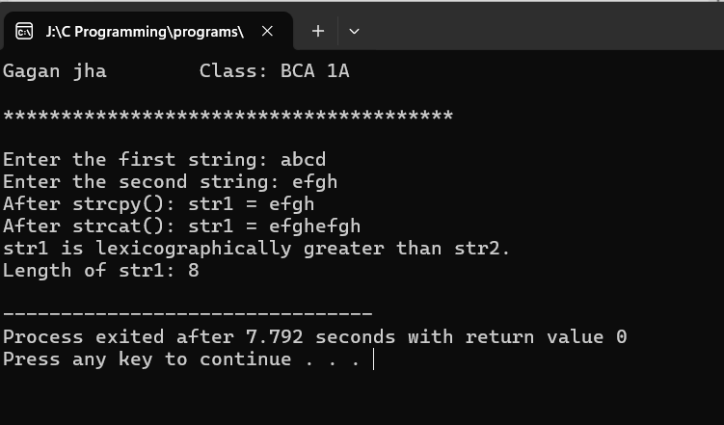**OUTPUT**

**53 Program to find if a given string is palindrome or not.**

#include <stdio.h>

#include <string.h>

int isPalindrome(char *str) {

int length = strlen(str);

int i, j;

for (i = 0, j = length - 1; i < j; i++, j--) {

if (str[i] != str[j]) {

return 0; // Not a palindrome

}

}

return 1; // Palindrome

}

int main() {

printf("Gagan jha \t Class: BCA 1A\n");

printf("\n***************************************\n\n");

char str[100];

printf("Enter a string: ");

fgets(str, sizeof(str), stdin);

if (isPalindrome(str)) {

printf("%s is a palindrome.\n", str);

} else {

printf("%s is not a palindrome.\n", str);

}

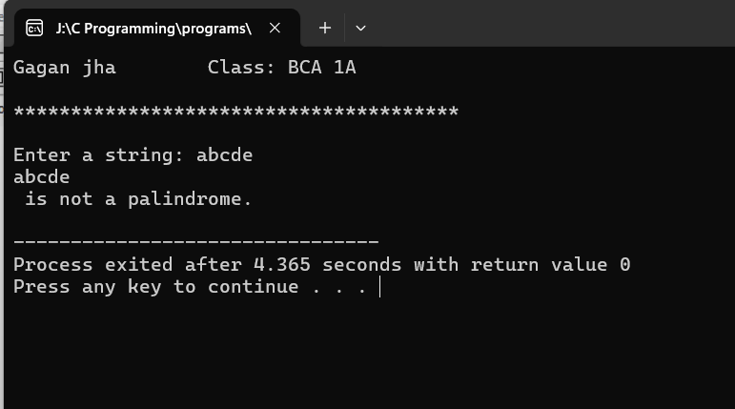 return 0;

}

**OUTPUT**

**54. Program to define pointer variables for int, char and float. Print their values (using *) and addresses using pointers.**

#include <stdio.h>

int main(){

printf("Gagan jha \t Class: BCA 1A\n");

printf("\n***************************************\n\n");

int num = 20;

char letter = 'G';

float pi = 3.14;

int *intPtr;

char *charPtr;

float *floatPtr;

intPtr = &num;

charPtr = &letter;

floatPtr = &pi;

printf("Value of num: %d, Address of num: %p\n", *intPtr, intPtr);

printf("Value of letter: %c, Address of letter: %p\n", *charPtr, charPtr);

printf("Value of pi: %.2f, Address of pi: %p\n", *floatPtr, floatPtr);

return 0;

} **OUTPUT**

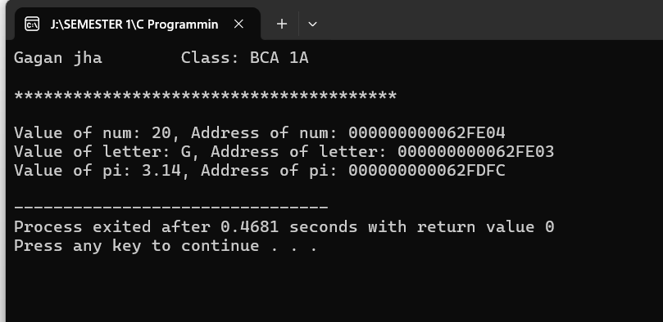

**55. Program using pointers to read array elements and find their sum.**

#include <stdio.h>

int main() {

printf("Gagan jha \t Class: BCA 1A\n");

printf("\n***************************************\n\n");

int n, sum = 0;

printf("Enter the number of elements in the array: ");

scanf("%d", &n);

int arr[n];

int *ptr = arr;

printf("Enter %d elements:\n", n);

for (int i = 0; i < n; i++) {

printf("Element %d: ", i + 1);

scanf("%d", ptr + i);

}

for (int i = 0; i < n; i++) {

sum += *(ptr + i);

}

printf("The sum of the array elements is: %d\n", sum);

return 0;

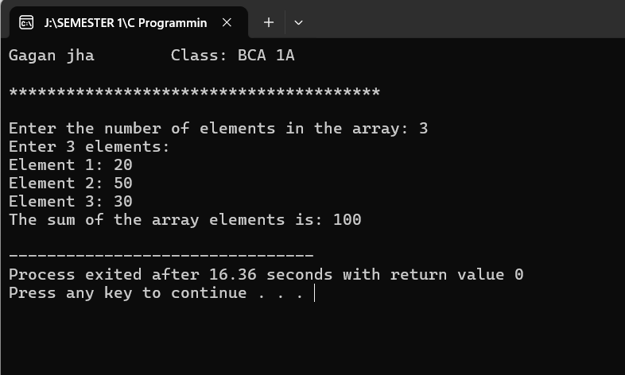}

**56. Program to find length of string using pointers.**

#include <stdio.h>

int main() {

printf("Gagan jha \t Class: BCA 1A\n");

printf("\n***************************************\n\n");

char str[100];

char *ptr;

int length = 0;

printf("Enter a string: ");

scanf("%s", str);

ptr = str;

while (*ptr != '\0') {

length++;

ptr++;

}

printf("Length of the string: %d\n", length);

return 0;

}

**OUTPUT**

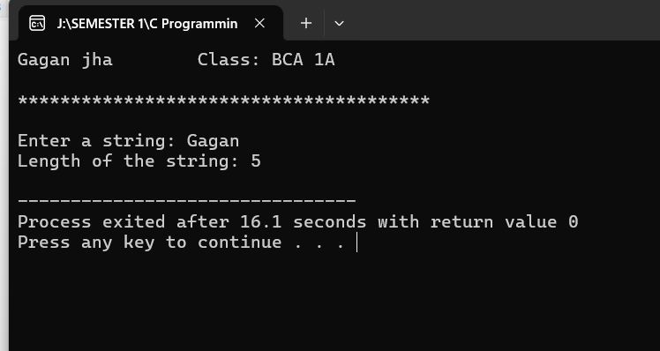

**57. Program to declare an array of pointers, read values and print them.**

#include <stdio.h>

#include <stdlib.h>

int main() {

printf("Gagan jha \t Class: BCA 1A\n");

printf("\n***************************************\n\n");

int n;

printf("Enter the number of elements: ");

scanf("%d", &n);

int **arr = (int **)malloc(n * sizeof(int *));

for (int i = 0; i < n; i++) {

arr[i] = (int *)malloc(sizeof(int));

printf("Enter value for element %d: ", i + 1);

scanf("%d", arr[i]); // Read value into the allocated memory

}

printf("\nThe values entered are:\n");

for (int i = 0; i < n; i++) {

printf("Element %d: %d\n", i + 1, *arr[i]);

}

for (int i = 0; i < n; i++) {

free(arr[i]);

}

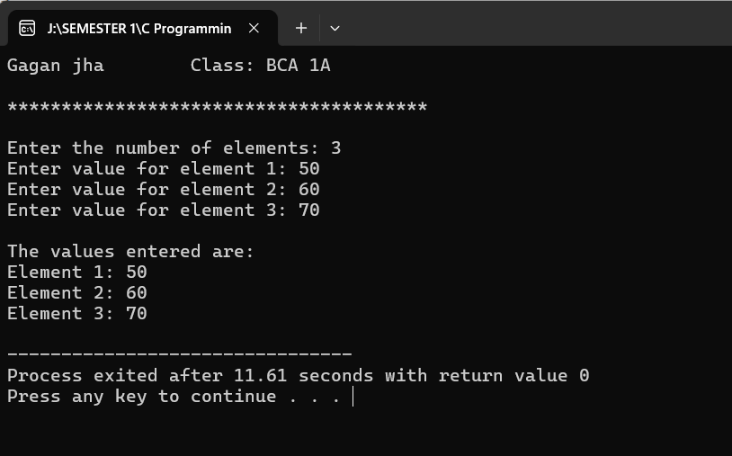 free(arr);

return 0;

}

**OUTPUT:-**

**58. Program to enter book records, using structures.**

#include <stdio.h>

#include <string.h>

struct Book {

int book_id;

char title[50];

char author[50];

float price;

};

int main() {

printf("Gagan jha \t Class: BCA 1A\n");

printf("\n***************************************\n\n");

struct Book book;

printf("Enter book details:\n");

printf("Book ID: ");

scanf("%d", &book.book_id);

printf("Title: ");

scanf("%s", book.title);

printf("Author: ");

scanf("%s", book.author);

printf("Price: ");

scanf("%f", &book.price);

printf("\nBook Details:\n");

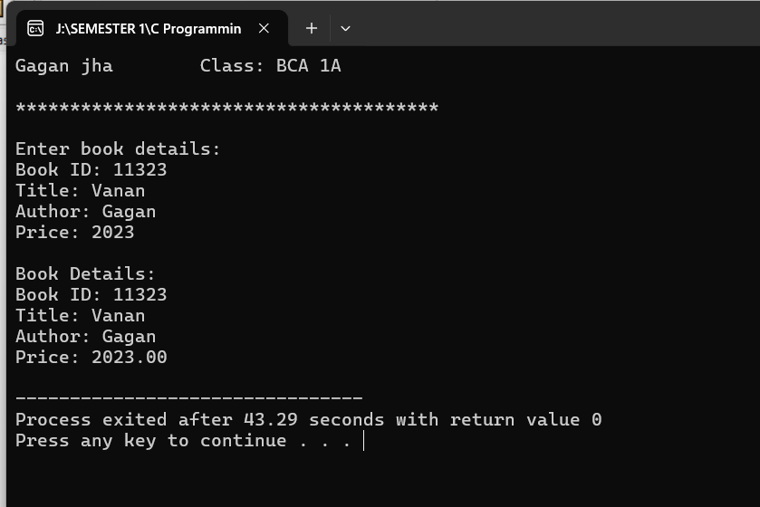 printf("Book ID: %d\n", book.book_id);

printf("Title: %s\n", book.title);

printf("Author: %s\n", book.author);

printf("Price: %.2f\n", book.price);

return 0;

}

**OUTPUT:-**

**59. Program to enter employee salary records, using structures. Create array of structures.**

#include <stdio.h>

#include <string.h>

struct Employee {

int id;

char name[50];

float salary;

};

int main() {

printf("Gagan jha \t Class: BCA 1A\n");

printf("\n***************************************\n\n");

int n, i;

printf("Enter the number of employees: ");

scanf("%d", &n);

struct Employee employees[n];

printf("\nEnter employee details: \n\n");

for (i = 0; i < n; i++) {

printf("Employee %d:\n", i + 1);

printf("ID: ");

scanf("%d", &employees[i].id);

printf("Name: ");

scanf("%s", employees[i].name);

printf("Salary: ");

scanf("%f", &employees[i].salary);

}

printf("\nEmployee Records:\n");

for (i = 0; i < n; i++) {

printf("Employee %d:\n", i + 1);

printf("ID: %d\n", employees[i].id);

printf("Name: %s\n", employees[i].name);

printf("Salary: %.2f\n", employees[i].salary);

}

return 0;

}

**OUTPUT**

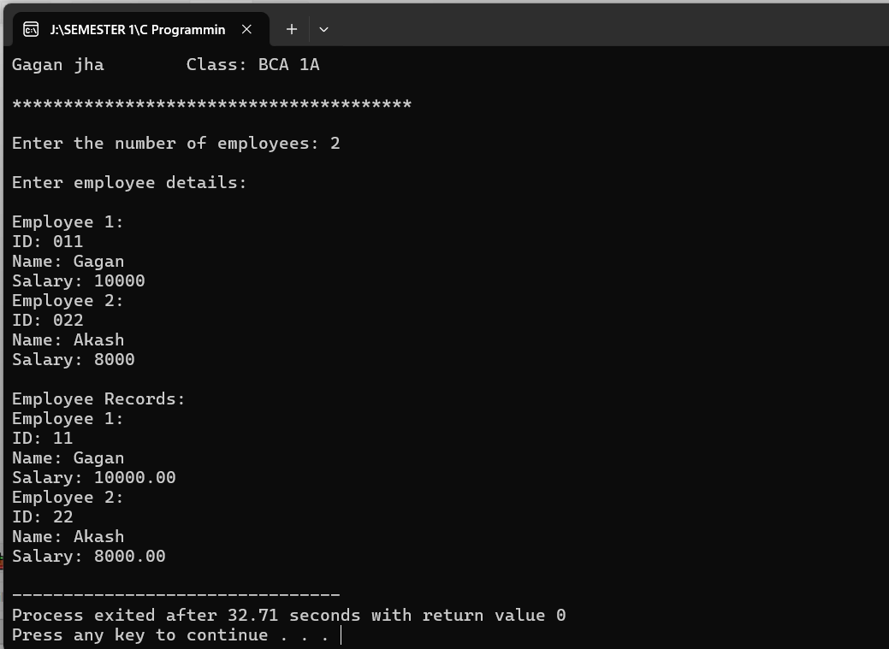

**60. Program to define a structure stores and write a function update() to change the values of its members. (Pass structure to update() and return structure.**

#include <stdio.h>

#include <string.h>

struct Store {

char name[100];

char location[100];

float revenue;

};

struct Store update(struct Store s) {

printf("\nEnter new store name: ");

fgets(s.name, sizeof(s.name), stdin);

size_t len = strlen(s.name);

if (len > 0 && s.name[len - 1] == '\n') {

s.name[len - 1] = '\0';

}

printf("Enter new store location: ");

fgets(s.location, sizeof(s.location), stdin);

len = strlen(s.location);

if (len > 0 && s.location[len - 1] == '\n') {

s.location[len - 1] = '\0';

}

printf("Enter new revenue: ");

scanf("%f", &s.revenue);

return s;

}

int main() {

printf("Gagan jha \t Class: BCA 1A\n");

printf("\n***************************************\n\n");

struct Store myStore = {"Electronics", "Pitampura", 100000.50};

printf("Original Store Details:\n");

printf("Name: %s\n", myStore.name);

printf("Location: %s\n", myStore.location);

printf("Revenue: %.2f\n", myStore.revenue);

myStore = update(myStore);

printf("\nUpdated Store Details:\n");

printf("Name: %s\n", myStore.name);

printf("Location: %s\n", myStore.location);

printf("Revenue: %.2f\n", myStore.revenue);

return 0;

}

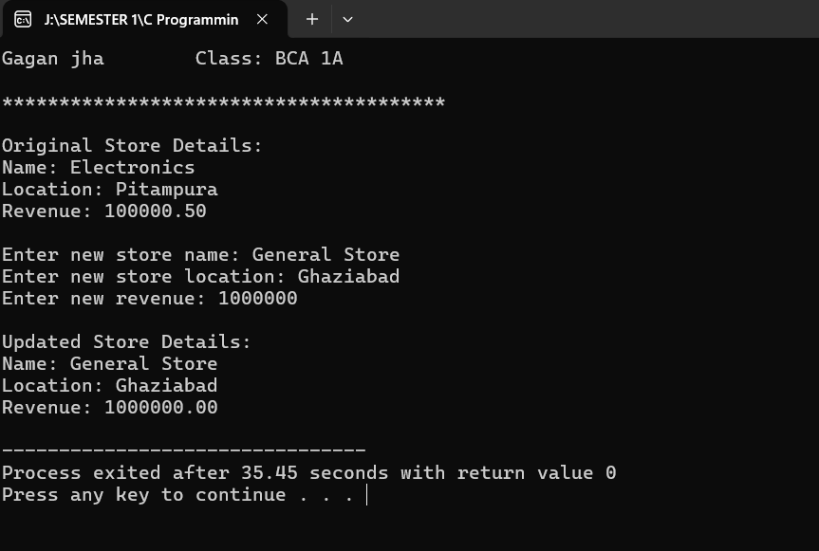 **OUTPUT**